# Python Investment

## Introduction to Python for Finance

### Visualization in Python

#### Histograms

* Important questions:



## Intermediate Python for Finance

### Datetimes and Dictionaries

#### Manipulating dates with datetimes

* Creating an object:

black_monday = datetime.datetime(1987, 10, 19)

print(black_monday)

result:

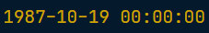

* Datetime from string (parsing):

crash_text = "Friday the 13th, Oct, 1989"

crash_format_str = '%A the %dth, %b, %Y'

min_crash = datetime.datetime.strptime(crash_text, crash_format_str)

print(min_crash)

result:



* String format of the date:

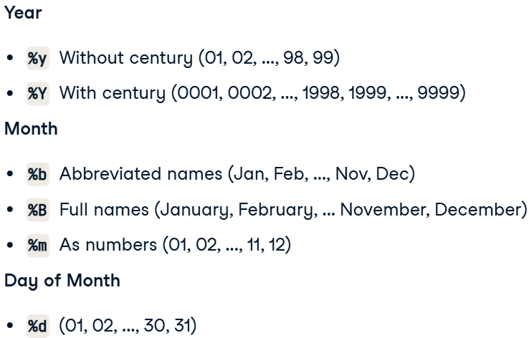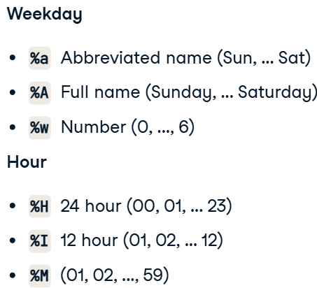

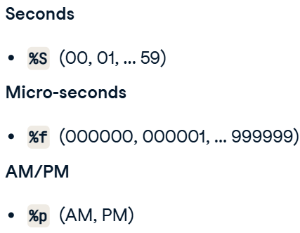

* String from datetime (formatting):

org_text = "Sep 16 1992"

org_format = "%b %d %Y"

black_wednesday = datetime.datetime.strptime(org_text, org_format)

print(black_wednesday)

new_format = '%A, %B %d, %Y'

new_text = datetime.datetime.strftime(black_wednesday, new_format)

print(new_text)

result:

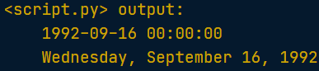

#### Working with datetimes

* Datetime attributes:

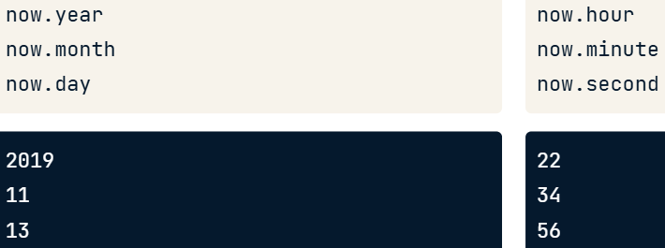

* Comparing datetimes:
  + greater (later);
  + less (before).
* Difference between datetimes (aspect #3 means using attributes inside the func):

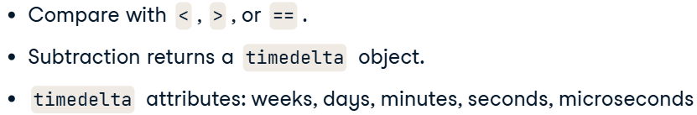

* Creating relative datetimes (allowing to cross month’s and year’s boundaries):

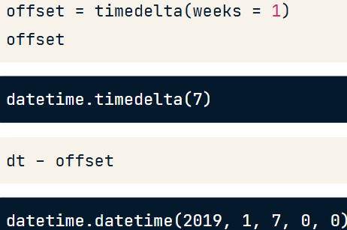

* + Code:

from datetime import datetime, timedelta

tarp = datetime(2008, 10, 3)

year_after = tarp + timedelta(weeks=52)

print(year_after)

#### Dictionaries

* .get(value, default_value) – method, which prevents from raising an error due to taking not exsisting error.
  + Code:

print(alphabet_hist.get(future_closing_price_date, 'Missing'))

* add a new value:

cusip_lookup['037833100'] = 'AAPL'

* removing:

del alphabet_hist[closing_price_date]

### Pandas Dataframe

#### Extending and manipulating data

* Map vs Apply:



#### Plotting

* Plot types:

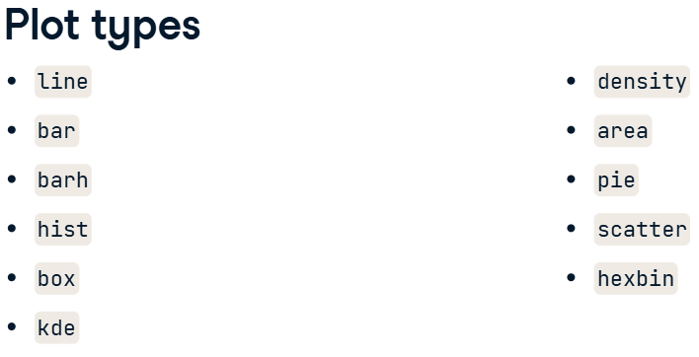

## Data Manipulation with pandas

### Transforming DataFrames

#### Introducing DataFrames

* df.info() – shows information on each of the columns, such as the data type and number of missing values.
* df.describe() – gives a summary statistics of df.
  + df.describe(include=[]) – includes several types of columns in df.
  + df.describe(percentiles=[0.1, 0.5]) – lets you to change default percentile stats.
  + df.describe(exclude=[]) – works in opposite way to “include”.
* df.colums – gives info about columns of the df.
* df.index – gives info about rows of the df.

#### Sorting and subsetting

* df.sort_values(‘column’) – sorts the values of the df.
  + code for multiple sorting:

homelessness_reg_fam = homelessness.sort_values(['region', 'family_members'],

                                                ascending=[True, False])

print(homelessness_reg_fam.head())

* Subsetting:
  + Boolean operators:



* + Code:

fam_lt_1k_pac = homelessness[(homelessness['family_members'] < 1000) &

                                (homelessness['region'] == 'Pacific')]

print(fam_lt_1k_pac)

* isin() – filters multiple values of a categorical column.
  + code:

canu = ["California", "Arizona", "Nevada", "Utah"]

mojave_homelessness = homelessness[homelessness['state'].isin(canu)]

print(mojave_homelessness)

### Aggregating DataFrames

#### Summary statistics

* DataFrame methods:

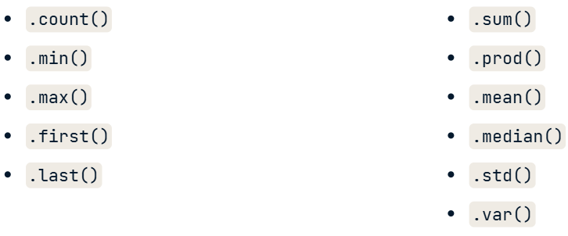

* df.agg() – aggregate values.
  + code for multiple agg_funcs:

import numpy as np

iqr = lambda x: x.quantile(0.75) - x.quantile(0.25)

print(sales[['temperature_c',

            'fuel_price_usd_per_l',

            'unemployment']].agg([iqr, np.median]))

result:

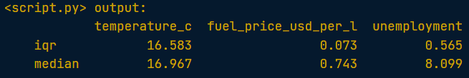

* Cumulative statistics (after sorting on specific column):

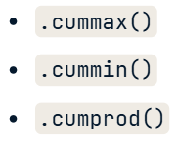

* + code:

sales_1_1['cum_max_sales'] = sales_1_1.weekly_sales.cummax()

#### Counting

* df.drop_duplicates(subset=’column’) – drop duplicates in column.
  + code:

store_types = sales.drop_duplicates(['store', 'type'])

print(store_types.head())

* df.value_counts() – counts categories in column (arg normalize to learn proportion).
  + code:

dept_props_sorted = store_depts.department.value_counts(normalize=True, sort=True)

print(dept_props_sorted)

#### Grouped summary statistics

* df.groupby(‘column’) – groups data by column.
  + code:

sales_by_type_is_holiday = sales.groupby(["type", "is_holiday"])["weekly_sales"].sum()

print(sales_by_type_is_holiday)

#### Pivot tables

* df.pivot_table() – can be used instead of groupby to get summary.
  + code:

print(sales.pivot_table(values="weekly_sales",

                        index="department",

                        columns="type",

                        fill_value=0,

                        margins=True))

* + margins – provides with totals by rows and columns.

result:

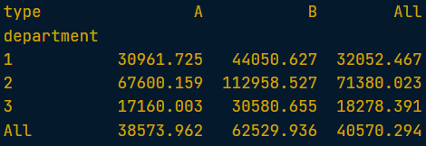

### Slicing and Indexing DataFrames

#### Explicit indexes

* df.set_index() – setting the index of the DF.
  + code:

print(temperatures_ind.head())

* df.reset_index() – resetting the index of the DF with and without dropping.
  + code:

print(temperatures_ind.reset_index())

print(temperatures_ind.reset_index(drop=True))

* df.sort_index() – sorting index values in dataframe.

print(temperatures_ind.sort_index(level=['city']))

print(temperatures_ind.sort_index(level=['country', 'city'],

                                    ascending=[True, False]))

* + You can only slice an index if the index is sorted (using .sort_index()).

#### Slicing and subsetting with .loc and .iloc

* Creating mask with using loc:

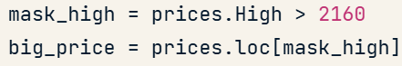

* Slicing with multiindex:

print(temp_by_country_city_vs_year.loc[('Egypt','Cairo'):('India','Delhi'),

                                        "2005":"2010"])

### DataFrames

#### Missing values

* Detecting missing values:
  + When you replace missing values, you make assumptions about what a missing value means!
  + df.isna().any() – if at least one missing value in a column
    - code:

avocados_2016.isna().any()

* + df.isna().sum() – all the missing values in each row.
    - code:

avocados_2016.isna().sum()

* Removing missing values:
  + df.dropna()
* Replacing missing values:
  + df.fillna()

#### Creating DataFrames

* list of dictionaries:
  + code:

avocados_list = [

    {'date':"2019-11-03", 'small_sold':10376832, 'large_sold':7835071},

    {'date':"2019-11-10", 'small_sold':10717154, 'large_sold':8561348}

]

avocados_2019 = pd.DataFrame(avocados_list)

print(avocados_2019)

* dict of lists:
  + code:

avocados_dict = {

  'date': ["2019-11-17", "2019-12-01"],

  'small_sold': [10859987, 9291631],

  'large_sold': [7674135, 6238096]

}

avocados_2019 = pd.DataFrame(avocados_dict)

print(avocados_2019)

* Saving DataFrame on PC:

airline_totals_sorted.to_csv('airline_totals_sorted.csv')

## Introduction to Financial Concepts in Python

### The Time Value of Money

* Course Objective:

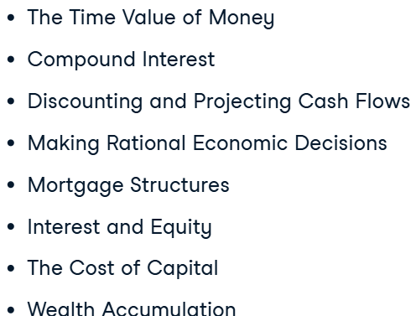

#### Fundamental financial concepts

* Rate of Return:

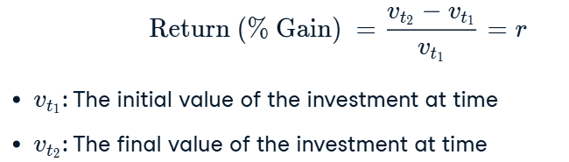

* Dollar value of an investment (in future):

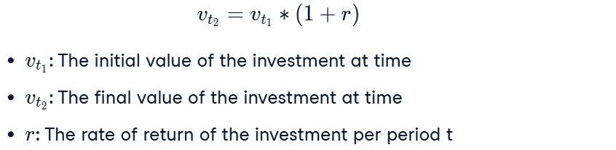

* Cumulative growth (Future value):

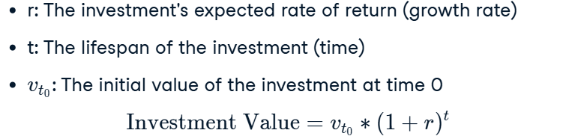

* + discount factor (to learn initial value of the investment):

1 / ((1 - 0.05)**(30)) ~ 1.67

* Discounting:

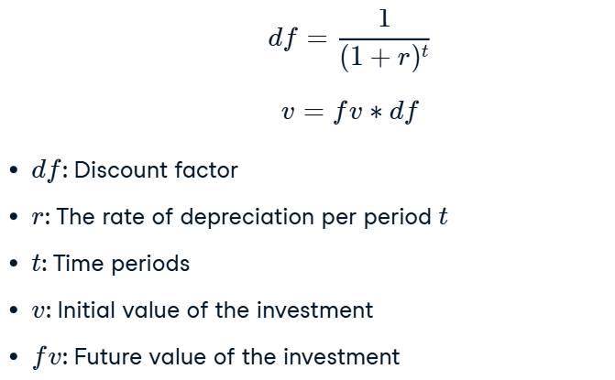

* Compound interest (Future value):

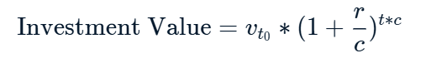

#### Present and future value

* Present Value (PV):
  + *fv* must be positive, as we get money

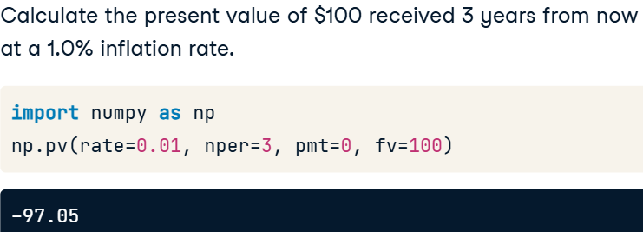

* Future Value (FV):
  + *pv* must be negative, as we make an invesmnt (spend money)

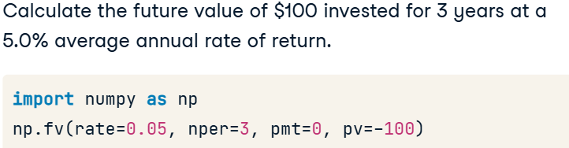

* Params of functions:
  + rate: The rate of return of the investment;
  + nper: The lifespan of the investment;
  + pmt: The (fixed) payment at the beginning or end of each period;
    - begin=1; end=0.
  + fv: The future value of the investment.
* Example (FV + PV):
  + Code:

import numpy as np

investment_1 = np.fv(rate=0.08,

                        nper=10,

                        pmt=0,

                        pv=-10000)

print("Investment 1 will yield a total of $" + str(round(investment_1, 2)) + " in 10 years")

investment_1_discounted = np.pv(rate=0.03,

                                nper=10,

                                pmt=0,

                                fv=investment_1)

print("After adjusting for inflation, investment 1 is worth $" + str(round(-investment_1_discounted, 2)) + " in today's dollars")

result:



### Making Data-Driven Financial Decisions

#### A tale of two project proposals

* Profitability analysis methods:

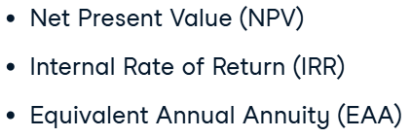

* Net Present Value (*NPV*):
  + what is it:

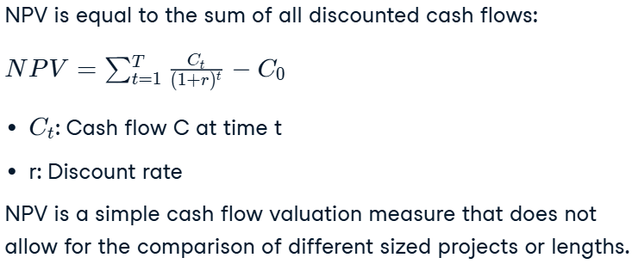

* + code:

cash_flows = np.array([100, 100, 100, 100, 100])

investment_1 = np.npv(rate=0.03, values=cash_flows)

print("Investment 1's net present value is $" + str(round(investment_1, 2)) + " in today's dollars")

result:



* Internal Rate of Return (*IRR*):
  + what is it:

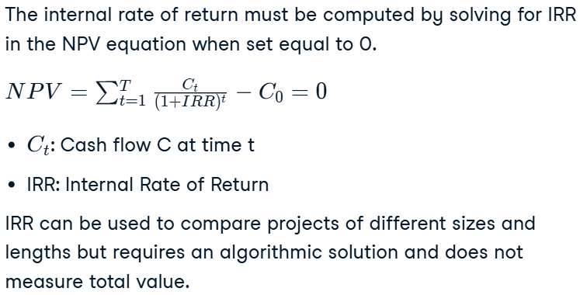

* + code:

irr_project2 = np.irr(cf_project2)

print("Project 2 IRR: " + str(round(100*irr_project2, 2)) + "%")

result:

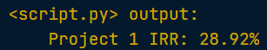

#### The Weighted Average Cost of Capital

* Propotion of financing:

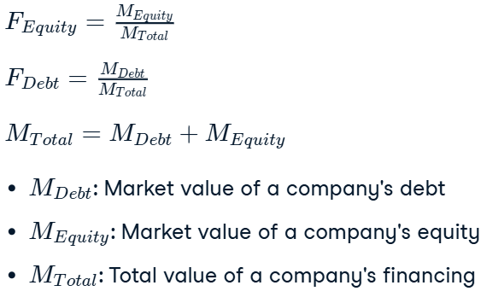

* The cost of debt financing can be estimated as the amount you will have to pay on a new loan. This can be estimated by looking at the interest rates of loans of similar sizes to similar companies, or could be based on previous loans your company may already have been issued.
* The cost of equity financing can be estimated as the return on equity of similar companies. Calculating the return on equity is a simple accounting exercise, but all you need to know is that essentially, investors will require a rate of return that is close to what could be earned by a similar investment.
* Сompanies adjust the cash flows of potential projects by their cost of financing (the WACC) to account for their investor's required rate of return based on market conditions.

#### Comparing two projects of different life spans

* Pay attention to NPV.
* Pay attention to IRR.
* Equivalent Annual Annuity (EAA) – can be used to compare two projects of different lifespans in present value term.
  + Each project is a loan, that pays out every year some amount, totaling the NPV of the project at the end of the period, generating a flat interest each year.
  + Comparing NPV relative to the life period of the project.
* Code for EAA:

eaa_project1 = np.pmt(rate=wacc,

                        nper=8,

                        pv=-npv_project1,

                        fv=0)

print("Project 1 EAA: " + str(round(eaa_project1, 2)))

result:



### Simulating a Mortgage Loan

#### Mortgage basics

* From annual to *compounded* periodic rate (effective rate):

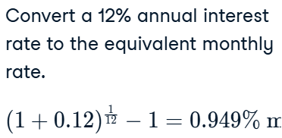

* + Для расчёта эквивалентной ставки важно исходить от **эффективной годовой ставки**.
  + Если у вас **номинальная ставка**, то сначала преобразуйте её в **эффективную** (учитывая капитализацию), а затем, если нужно, переведите её в периодическую ставку (например, месячную).
  + Если ставка уже **эффективная**, можно сразу извлечь **корень** или использовать её для расчёта эквивалентных периодических ставок.
* Mortgage loan process:

home_value = 800000

down_payment_percent = 0.2

down_payment = home_value * down_payment_percent

mortgage_loan = home_value - down_payment

print("Mortgage Loan: " + str(mortgage_loan))

mortgage_rate = 0.0375

mortgage_rate_periodic = (1 + mortgage_rate)**(1/12) - 1

mortgage_payment_periods = 30 * 12

periodic_mortgage_payment = np.pmt(rate = mortgage_rate_periodic,

                                    nper = mortgage_payment_periods,

                                    pv = -mortgage_loan,

                                    fv = 0)

print("Monthly Mortgage Payment: " + str(round(periodic_mortgage_payment, 2)))

result:

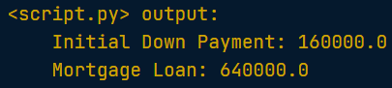

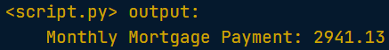

#### Amortization, interest and principal

* How interest is accounted (principal and interest payment):

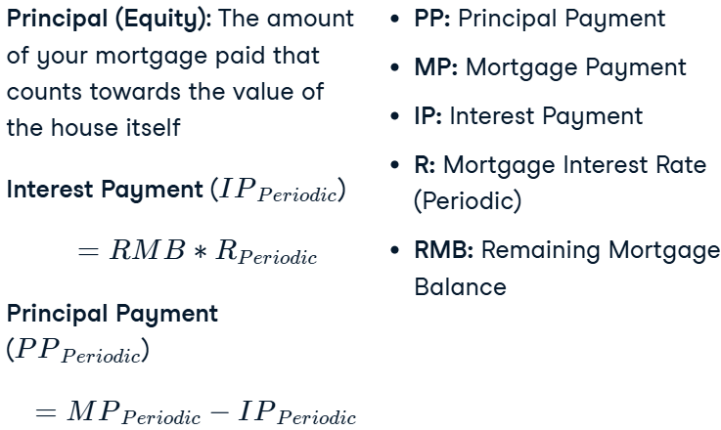

* Paying out:

# Loop through each mortgage payment period

for i in range(mortgage_payment_periods):

    # Handle the case for the first iteration

    if i == 0:

        previous_principal_remaining = mortgage_loan

    else:

        previous_principal_remaining = principal_remaining[i-1]

    # Calculate the interest based on the previous principal

    interest_payment = round(previous_principal_remaining*mortgage_rate_periodic, 2)

    principal_payment = round(periodic_mortgage_payment - interest_payment, 2)

    # Catch the case where all principal is paid off in the final period

    if previous_principal_remaining - principal_payment < 0:

        principal_payment = previous_principal_remaining

    # Collect the historical values

    interest_paid[i] = interest_payment

    principal_paid[i] = principal_payment

    principal_remaining[i] = previous_principal_remaining - principal_payment

# Plot the interest vs principal

plt.plot(interest_paid, color="red")

plt.plot(principal_paid, color="blue")

plt.legend(handles=[interest_plot, principal_plot], loc=2)

plt.show()

result:

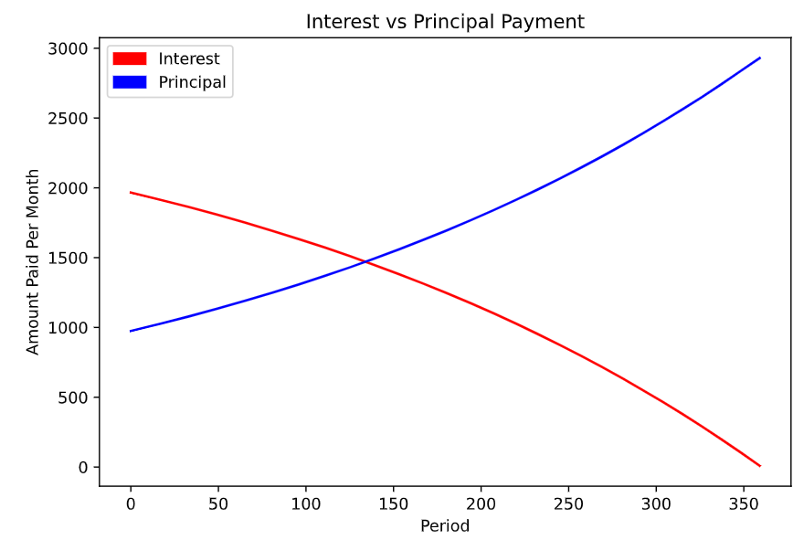

#### Home ownership, equity and forecasting

* Percantage of the ownership:

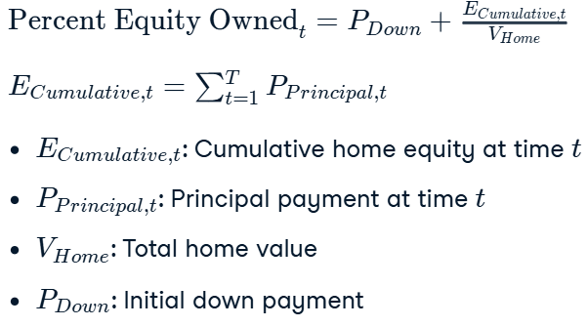

* Underwater mortage:



* + How to manage:
    - The best case scenario is either refinancing (which is a restructuring of the loan);
    - Continuing to pay the mortgage off in hopes that housing prices will rise.
* Forecasting cumulative growth of principal and interest paid:

cumulative_home_equity = np.cumsum(principal_paid)

cumulative_interest_paid = np.cumsum(interest_paid)

cumulative_percent_owned = (down_payment_percent * home_value) / home_value + cumulative_home_equity / home_value

print(cumulative_percent_owned)

# Plot the cumulative interest paid vs equity accumulated

plt.plot(cumulative_interest_paid, color='red')

plt.plot(cumulative_home_equity, color='blue')

plt.legend(handles=[interest_plot, principal_plot], loc=2)

plt.show()

result:

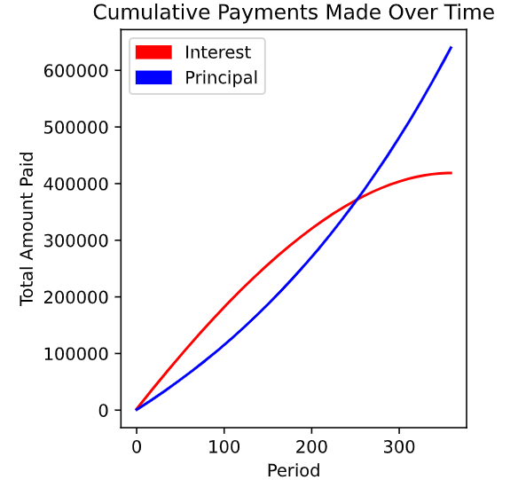

* When the price of the house is rising:

cumulative_growth_forecast = np.cumprod(1 + growth_array)

home_value_forecast = cumulative_growth_forecast * home_value

# Forecast the home equity value owned over time

cumulative_home_value_owned = cumulative_percent_owned * home_value_forecast

# Plot the home value vs equity accumulated

plt.plot(home_value_forecast, color='red')

plt.plot(cumulative_home_value_owned, color='blue')

plt.legend(handles=[homevalue_plot, homeequity_plot], loc=2)

plt.show()

result:

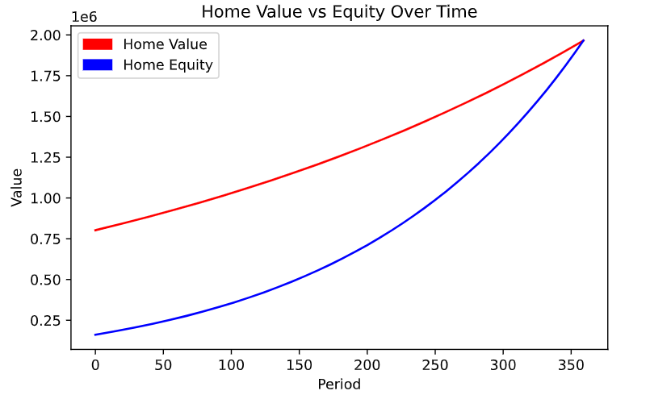

* When the price of the house is falling:

cumulative_decline_forecast = np.cumprod(1 + decline_array)

home_value_forecast = home_value * cumulative_decline_forecast

underwater = principal_remaining > home_value_forecast

print(pd.value_counts(underwater))

plt.plot(home_value_forecast, color='red')

plt.plot(principal_remaining, color='blue')

plt.legend(handles=[homevalue_plot, principal_plot], loc=2)

plt.show()

result:

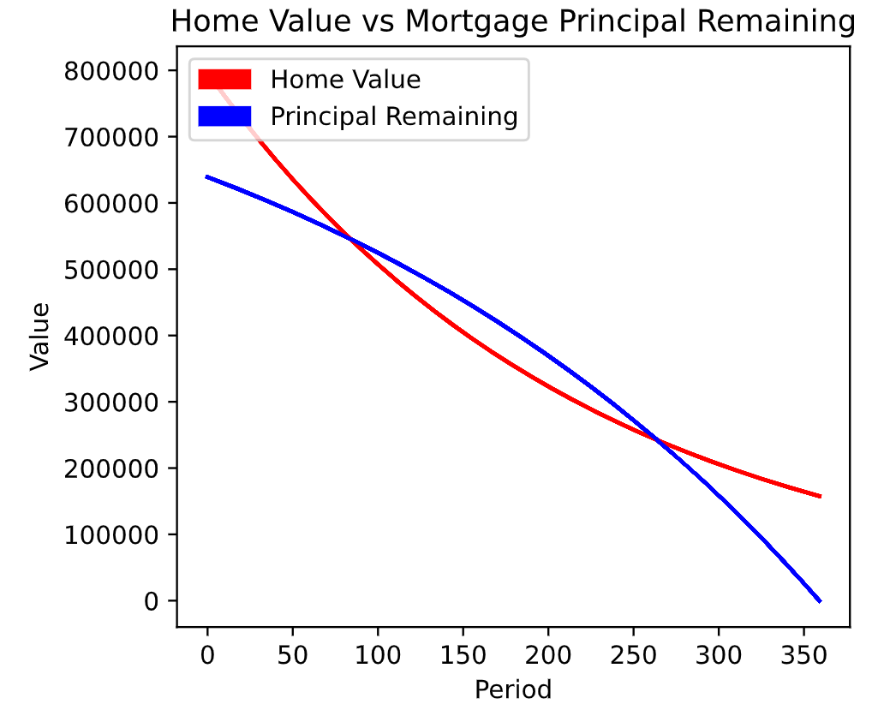 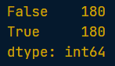

* + How to handle it:

 When the blue line is above the red line, you are *'underwater'*. Putting more money down and taking a smaller mortgage in the first place will help you avoid this situation.

### Budgeting Application

#### Budgeting project proposal

* Structure:

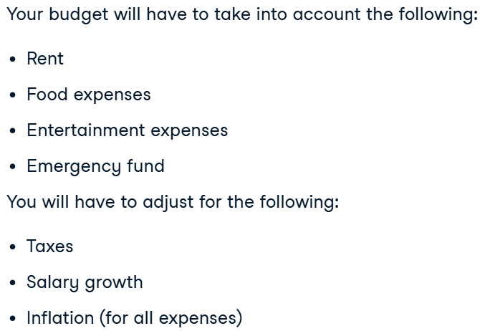

* Code:

<https://campus.datacamp.com/courses/introduction-to-financial-concepts-in-python/budgeting-application?ex=1>

#### Net worth and valuation in your personal financial life

* Net worth:



* Reaching financial goals:

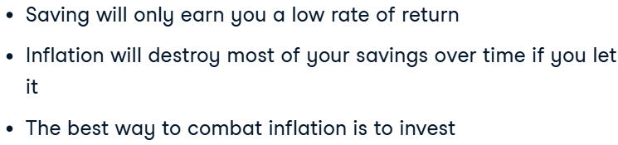

* Getting a millione in future:

# Set the annual investment return to 7%

investment_rate_annual = 0.07

# Calculate the monthly investment return

investment_rate_monthly = (1 + 0.07) ** (1/12) - 1

# Calculate your required monthly investment to amass $1M

required_investment_monthly = np.pmt(

    rate = investment_rate_monthly,

    nper = forecast_months,

    pv = 0,

    fv = -1000000

)

print("You will have to invest $" + str(round(required_investment_monthly, 2)) + " per month to amass $1M over 15 years")

* Assess future net worth:

for i in range(forecast_months):

    if i == 0:

        previous_investment = 0

    else:

        previous_investment = investment_portfolio[i - 1]

    investment_rate_monthly = (1 + 0.07) ** (1/12) - 1

    previous_investment_growth = previous_investment * (1 + investment_rate_monthly)

    investment_portfolio[i] = previous_investment_growth + investment_deposit_forecast[i]

    net_worth[i] = investment_portfolio[i] + cumulative_savings_new[i]

# Plot your forecasted cumulative savings vs investments and net worth

plot_investments(investment_portfolio, cumulative_savings_new, net_worth)

result:

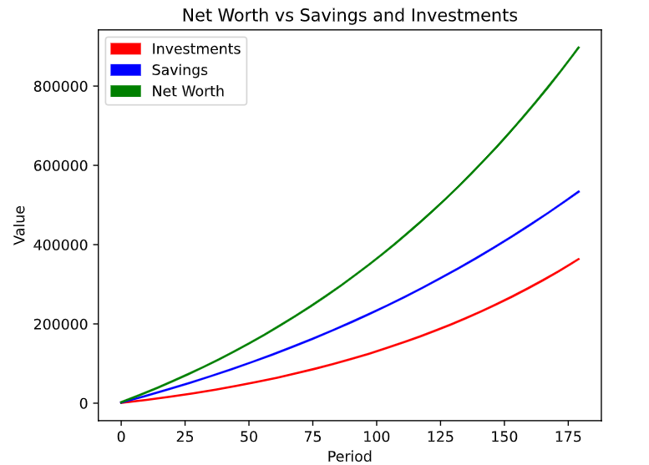

* Net worth discounting:

future_net_worth = 900000

annual_inflation = 2.5 / 100

# Calculate the present value of your terminal wealth over 15 years

inflation_adjusted_net_worth = np.pv(rate=annual_inflation,

                                        nper=15,

                                        pmt=0,

                                        fv=-future_net_worth)

print("Your inflation–adjusted net worth: $" + str(round(inflation_adjusted_net_worth, 2)))

result:

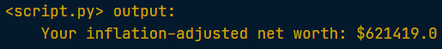

## Analyzing Financial Statements in Python

* Course Objective:



### The Balance Sheet

#### Computing financial ratios using pandas

* Balance sheet – a snapshot at a point of time of a company’s:
  + assets = liabilities + shareholders’ equity;
  + liabilities;
  + shareholders’ equity.
* Assets:
  + Current assets – refer to those class of assets that reap benefits to the business within one year.
    - accounts recieveble – дебіторська заборгованість.
  + Non-current assets – reap benefits over a longer period to the business.
    - property, plant and equipment – основні засоби.
  + Example:

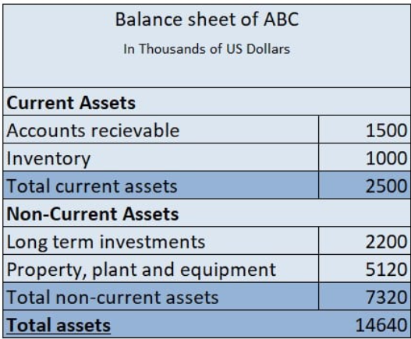

* Liabilities:
  + Current liabilities – usually to be repaid within one year.
    - accounts payble (the value of goods and services that a business purchases on credit) – кредиторська заборгованість.
  + Non-current liabilities – can be paid off after one year.
  + Example:

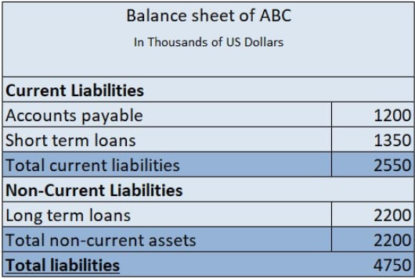

* Balance Sheet:

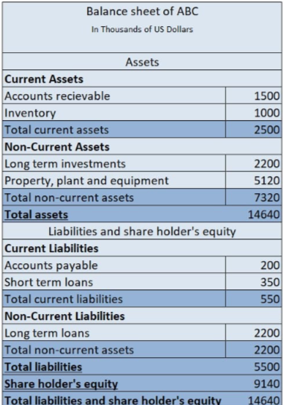

* Calculating liabilities:

accounts_receivable = 1356

inventory = 5420

long_term_investments = 7892

property_plant_equipment = 9840

shareholders_equity = 8000

# Add up total current assets

total_current_assets = accounts_receivable + inventory

# Add up total non-current assets

total_non_current_assets = long_term_investments + property_plant_equipment

# Compute total assets

total_assets = total_current_assets + total_non_current_assets

# Compute total liabilities

total_liabilities = total_assets - shareholders_equity

#### Financial ratios from the balance sheet

* Current Ratio:



* Debt-to-equity:
  + formula:

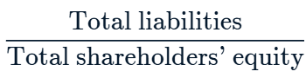

* + what is it:

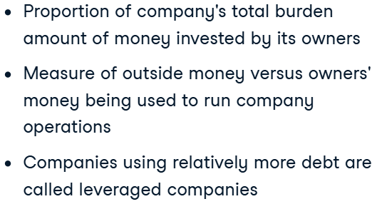

* Equity multiplier:
  + formula:

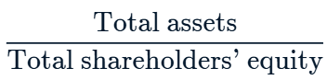

* + what is it:

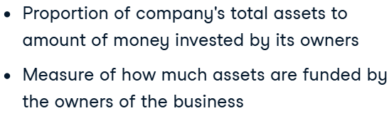

* Debt-to assets – gives a company’s ability to meet liabilities in general:
  + formula:

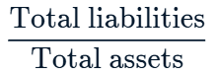

* + what is it:

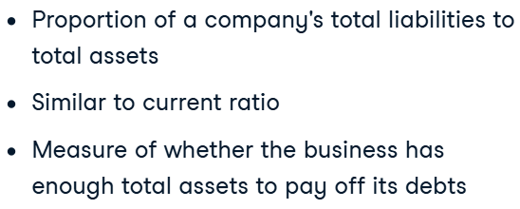

* Family of ratios:

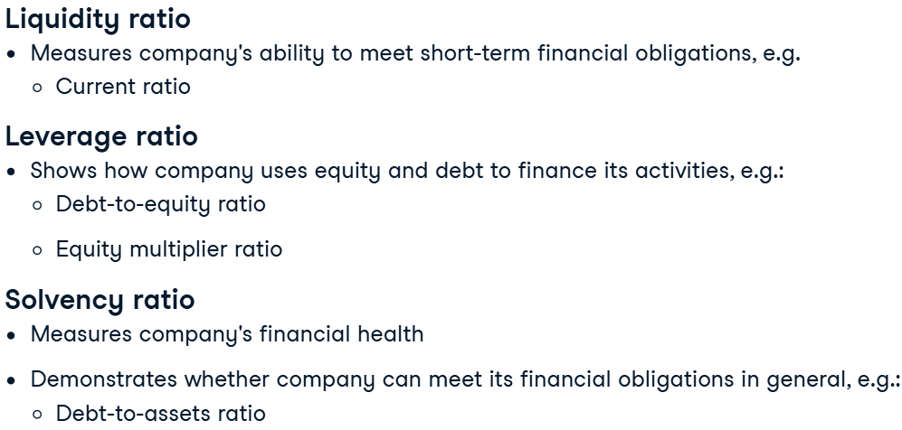

* + ratios computed using debt and equity are usually *leverage ratios*.
* Additional interpretation:
  + Running a company with too much debt might sound bad initially, but if it makes enough cash inflows to pay off its debts, having a lot of debt is not necessarily bad.
  + Similarly, having too much equity is not necessarily as beneficial as one might think. It might be inefficient because a company could be borrowing more money to grow its operations.

#### Computing financial ratios using pandas

* Idea:

An industry's ratio, on average gives us an overall idea of the industry's financial condition. On the other hand, an industry's ratio over time helps us understand its trends: is the ratio relatively stable or fluctuating over time? Is it improving or worsening?

* Grouping result to get industry’s assessment:



* Getting the industry mean values:
  + .transform() – can be used after .groupby() to append the group’s result to rows according to the group each row belongs to.
  + Code for compating metrics:

fmcg = balance_sheet[balance_sheet['comp_type'].isin(['fmcg'])]

fmcg["equity_multiplier_ratio"] = fmcg['Total Assets'] / fmcg['Total Stockholder Equity']

fmcg["average_equity_multiplier_ratio"] = fmcg.groupby('Year')["equity_multiplier_ratio"].transform('mean')

fmcg["relative_difference"] = (fmcg["equity_multiplier_ratio"] - fmcg["average_equity_multiplier_ratio"]) / fmcg["average_equity_multiplier_ratio"]

print(fmcg[["Year", "company", "relative_difference"]])

result:

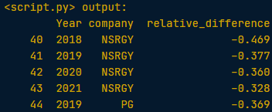

* Analyzing industry and it’s dynamics:

tech_fmcg = balance_sheet[balance_sheet['comp_type'].isin(['tech', 'fmcg'])]

groupby_industry = tech_fmcg.groupby('comp_type')[["current_ratio", 'debt_to_equity']].mean()

groupby_industry_time = tech_fmcg.groupby(['comp_type', 'Year'])[["current_ratio", "debt_to_equity"]].mean()

print(groupby_industry)

print(groupby_industry_time)

result:

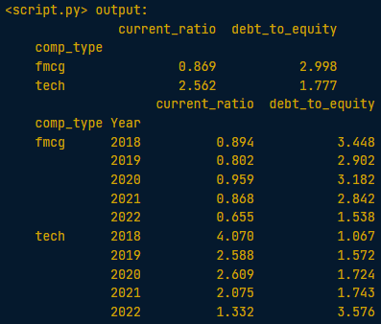

### The Income Statement

#### Introduction to the income statement

* The income statement – shows a company’s revenue and expanses over a period of time.
  + Revenue: by selling goods and services.
  + Expanses: costs are incured in the process.
    - Operating: are the consts to run the core operations of the business;
    - Non-operating: any other expanses.
* Income statements:
  + Revenue – доходы;
  + Profit – прибыль.
* Income statement:

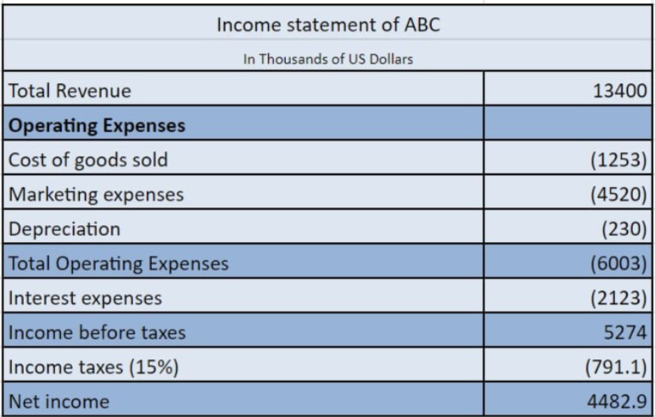

* Ratios:
  + Gross margin:
    - What is it:

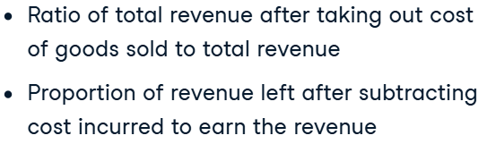

* + - Formula:



* + Operating margin:
    - What is it:

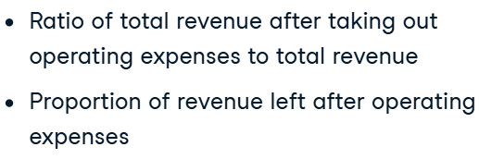

* + - Formula:

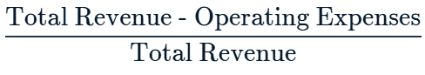

* Family of ratios (how efficiently a company uses its assets to earn money):

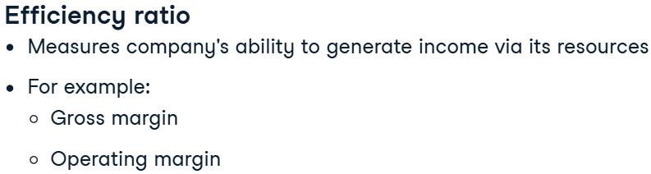

#### Ratios from the income statement and balance sheet

* Assets turnover ratio:
  + What is it:

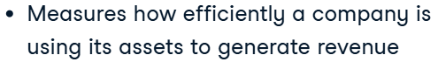

* + Formula:



* + Example:

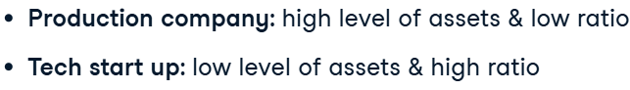

* Automating work (subtraction and addition) for METRICS:

def compute_ratio(df, numerator, denominator, ratio_name,

                  addition_in_numerator = True,

                  addition_in_denominator = True):

  numerator_of_ratio = np.where(addition_in_numerator,

                                df[numerator].sum(axis=1),

                                df[numerator[0]] - df[numerator[1:]].sum(axis=1))

  denominator_of_ratio = np.where(addition_in_denominator,

                               df[denominator].sum(axis=1),

                               df[denominator[0]] - df[denominator[1:]].sum(axis=1))

  df[ratio_name] = numerator_of_ratio/denominator_of_ratio

  return df

* + np.where checks if the first argument is True; if so, it returns the second argument, else it returns the third.
  + Application:

print(merged_dat.columns)

merged_dat = compute_ratio(merged_dat,

                        numerator = ['Total Revenue', 'Cost Of Revenue'],

                        denominator = ['Total Revenue'],

                        ratio_name = "gross_margin",

                        addition_in_numerator = False)

merged_dat = compute_ratio(merged_dat,

                        numerator = ['Total Revenue'],

                        denominator = ['Total Assets'],

                        ratio_name = "asset_turnover")

print(merged_dat.head())

/\

# Print the columns

print(merged_dat.columns)

list_of_ratio_names = ["asset_turnover", "gross_margin", "current_ratio"]

list_of_numerators = [["Total Revenue"],

              ["Total Revenue", "Cost Of Revenue"],

              ["Total Current Assets"]]

list_of_denominators = [["Total Assets"],

                      ["Total Revenue"],

                      ["Total Current Liabilities"]]

list_addition_in_numerator = [True, False, True]

list_addition_in_denominator = [True, True, True]

# Fill in the correct function here

for numerator, denominator, ratio_name, addition_in_numerator, addition_in_denominator in zip(list_of_numerators,

         list_of_denominators,

         list_of_ratio_names,

         list_addition_in_numerator,

         list_addition_in_denominator):

  merged_dat = compute_ratio(merged_dat, numerator, denominator, ratio_name, addition_in_numerator, addition_in_denominator)

print(merged_dat[list_of_ratio_names].head())

result:

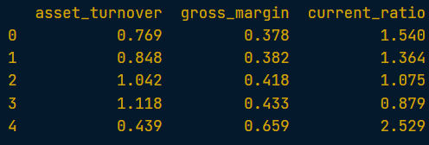

#### Visualizing ratios for within-company analysis

* Bar plots:

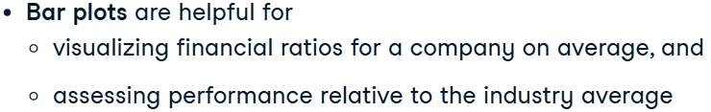

* Code for pivoting financial data:

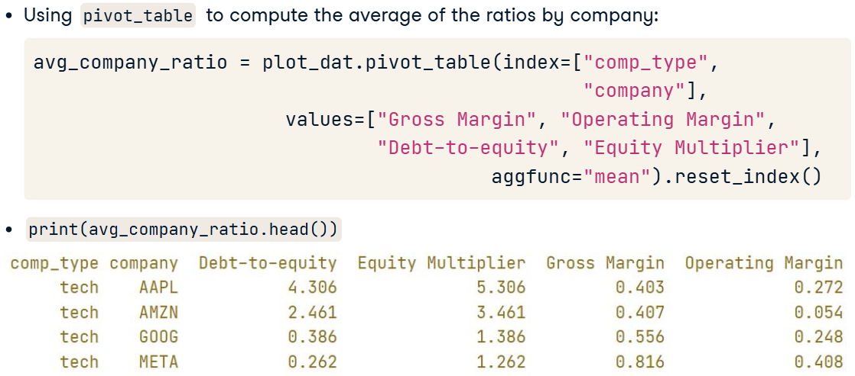

* Preparing data for plotting:

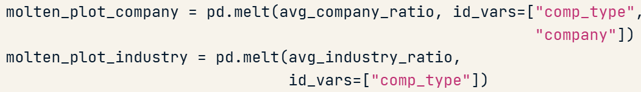

* + Comparing industy and companies:



* Plotting several aspects on one plot:

# Convert the DataFrame from wide to long

msft_melt = msft.melt(id_vars='Year',

                    value_vars=['asset_turnover', 'gross_margin'],

                    var_name="Ratio").reset_index()

# Plot the data

plot = sns.lineplot(msft_melt,

                    x='Year',

                    y='value',

                    hue='Ratio')

plt.show()

plot.xaxis.set_major_locator(MaxNLocator(integer=True))

plt.show()

### The Cash Flow Statement

#### Cash flow statement

* **Accrual method of accounting** – метод нарахування в обліку.
  + Example:

Suppose a customer purchases goods from a company and promises to pay later. This transaction would be recorded in the income statement at the moment the customer purchases the goods, not at the moment the customer pays money for the goods.

* Entries in the cash flow statement are related to the entries in the income statement and the balance sheet.
  + Example:

When a customer purchases goods on credit, the revenue is recorded in the income statement, and accounts receivable appear as an asset on the balance sheet. When the customer makes the payment, it is reflected as a cash inflow in the cash flow statement and as a reclassification of assets on the balance sheet, where accounts receivable decrease and cash increases, without affecting total assets.

* **Cash flow statement**:



* Types of cash flows:

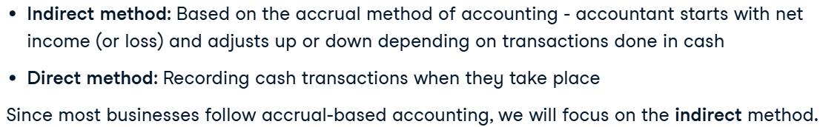

* + При косвенном методе расчёт начинается с прибыли, к которой прибавляются и вычитаются неденежные операции, эквивалентные притокам и оттокам средств.
  + В прямом методе учитываются только реальные денежные потоки: складываются поступления и вычитаются выплаты, чтобы получить чистое изменение денежного баланса.
* Structure of the cash flow statement:

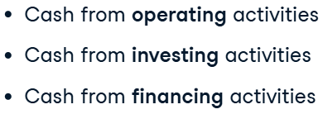

* Cash from *operating activities*:

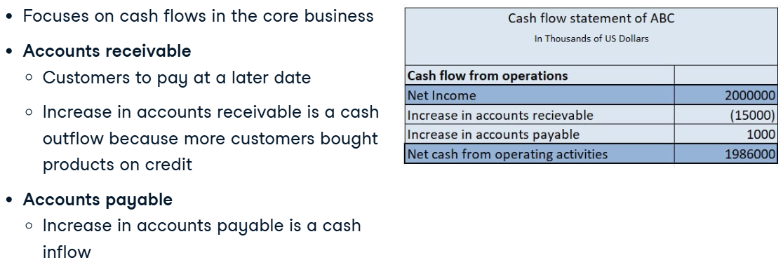

* Cash flow *investing activities*:

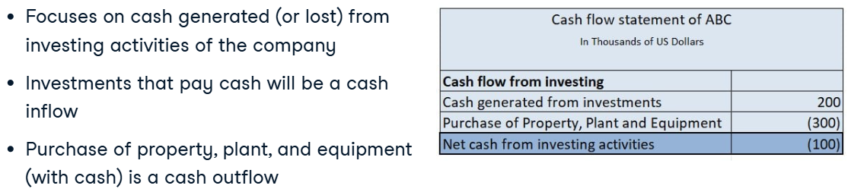

* Cash flow *financing activities*:

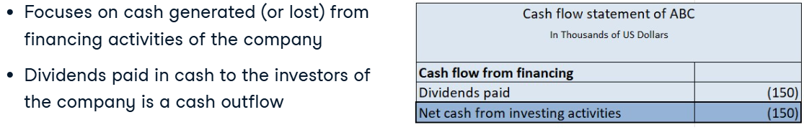

* All together (idirect method stars with “net profit”):

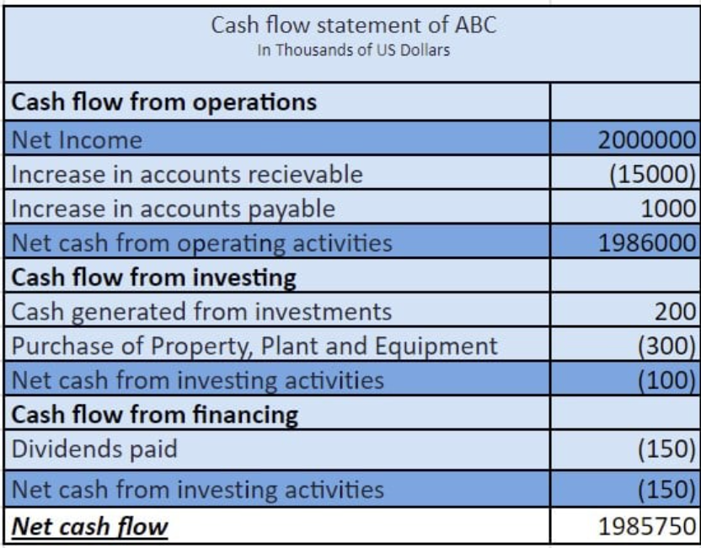

* Scheme:

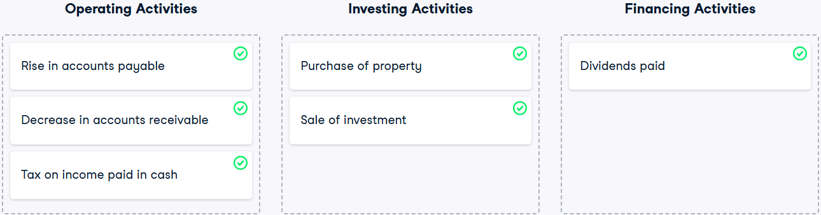

#### Financial ratios from the cash flow statement

* Cash flow to net income – the ideal value is greater than one (**profitability**):
  + What is it:

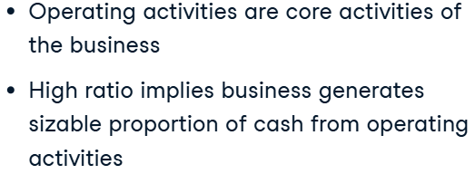

* + Formula:



* Operating cash flow – the ideal value is greater than one (**profitability**):
  + What is it:

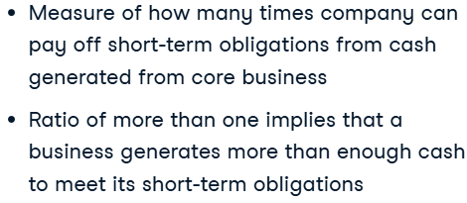

* + Formula:



* Handling missing data:



* + How to handle:

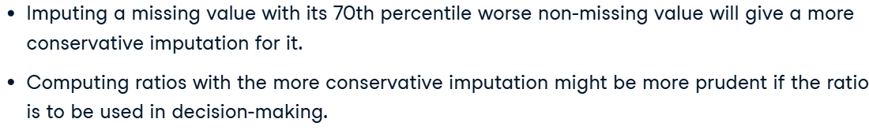

* + - might be more prudent – може бути більш розсудливим.
* Code for ratio computing:

print(merged_dat.columns)

merged_dat["cash_flow_to_net_income"] = merged_dat["Total Cash From Operating Activities"] / merged_dat["Net Income"]

merged_dat["operating_cash_flow"] = merged_dat["Total Cash From Operating Activities"] / merged_dat["Total Current Liabilities"]

# Compute the average ratios

average_ratios = merged_dat.pivot_table(index='Year',

                                        values=['cash_flow_to_net_income',

                                                'operating_cash_flow'])

print(average_ratios)

result:

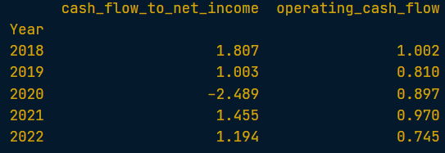

* Code for imputing missing values (by 70-th percentile):

impute_by_company = dataset.groupby("company")["Total Current Liabilities"].transform(lambda x: np.nanquantile(x, 0.7))

dataset["current_liab_quant_comp"] = dataset['Total Current Liabilities'].fillna(impute_by_company)

print(dataset)

#### Visualizing financial ratios for comparison

* Code for comparisson two companies:

melt_data = pd.melt(plot_df,

                    id_vars=['Year', 'company'],

                    var_name='Ratio')

sns.relplot(data = melt_data,

            x = 'Year',

            y = 'value',

            hue = 'Ratio',

            col = 'company',

            kind = 'line')

plt.show()

result:

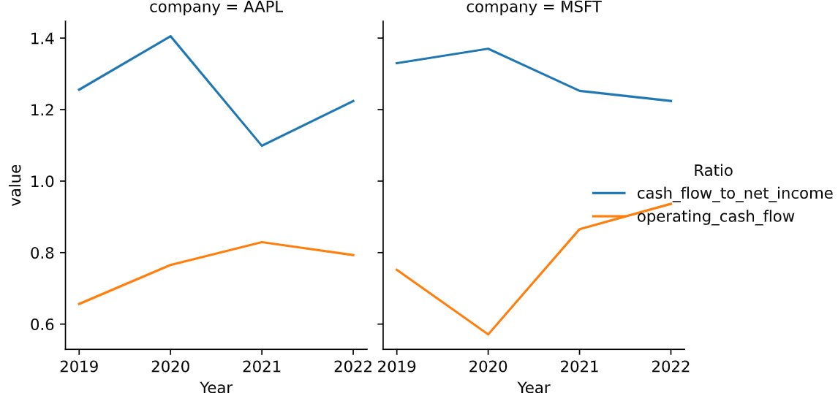

### Profitability metrics

#### Financial ratios

* Comparing industries and market at all:

dataset["debt_to_equity"] = dataset["Total Liab"]/dataset["Total Stockholder Equity"]

pivot_data = dataset.pivot_table(index = "comp_type", values = "debt_to_equity", margins=True)

sns.barplot(data = pivot_data.reset_index(),

            x = 'comp_type',

            y = 'debt_to_equity')

result:

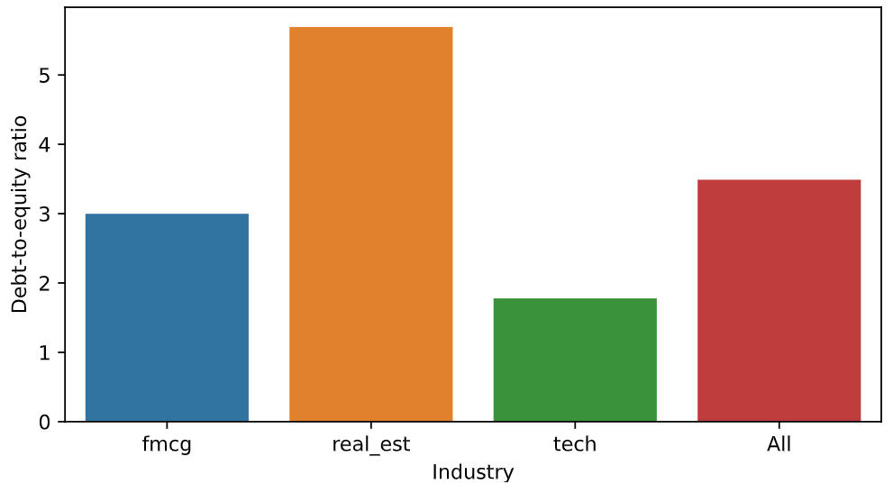

* Compating industries, companies inside them and industy_avg:

subset_dat = dataset.loc[dataset["comp_type"].isin(["tech", "fmcg"])]

subset_dat_avg = subset_dat.pivot_table(

                    index=["Year", "comp_type"],

                    values = "gross_margin").reset_index()

subset_dat_avg["company"] = np.where(subset_dat_avg['comp_type'] == 'tech',

                                    'Avg tech',

                                    'Avg fmcg')

plot_df = pd.concat([subset_dat, subset_dat_avg], axis=0)

sns.relplot(

    data = plot_df.reset_index(drop=True),

    x = 'Year',

    y = 'gross_margin',

    hue = 'company',

    col = 'comp_type',

    kind = 'line'

)

plt.show()

plt.close()

result:

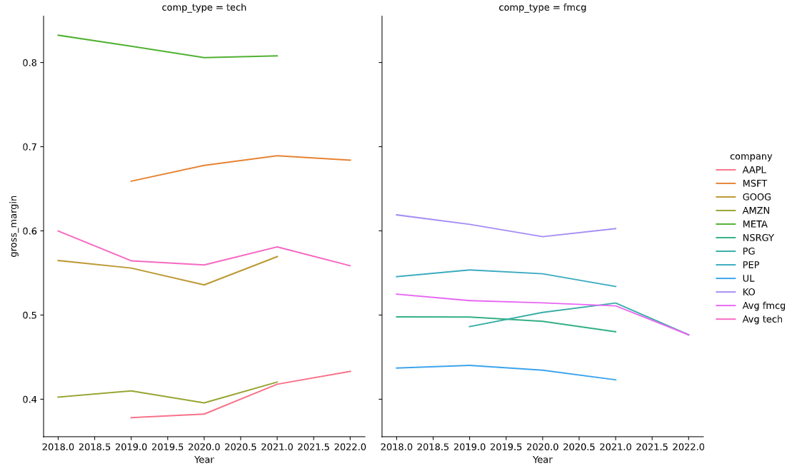

* Work automation:

def make_plot(dataset, ratio, comp_type (a list of industries)):

  whole_dat = []

  for industry in comp_type:

    dat = dataset.loc[dataset["comp_type"]==industry]

    dat_avg = dat.pivot_table(index="Year", values=ratio).reset_index()

    dat_avg["company"], dat_avg["comp_type"] = f"Avg {industry}", industry

    whole_dat.append(pd.concat([dat, dat_avg]))

  plot_df = pd.concat(whole_dat).reset_index(drop=True)

  # plot may be of any type

  sns.relplot(data=plot_df,

                x="Year",

                y=ratio,

                hue="company",

                col="comp_type", kind="line")

  plt.show()

  plt.close()

result:

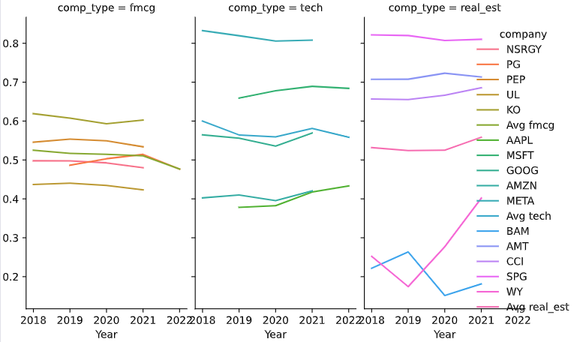

#### Profitability metrics

* Searching for a relationship between metrics:

dataset["operating_margin"] = (dataset["Total Revenue"] - dataset["Total Operating Expenses"]) / dataset["Total Revenue"]

dataset["debt_to_equity"] = dataset["Total Liab"]/dataset["Total Stockholder Equity"]

dataset_real_est = dataset.loc[dataset.comp_type.isin(['real_est'])]

sns.scatterplot(

    data = dataset_real_est,

    x = 'debt_to_equity',

    y = 'operating_margin')

plt.show()

plt.close()

result:

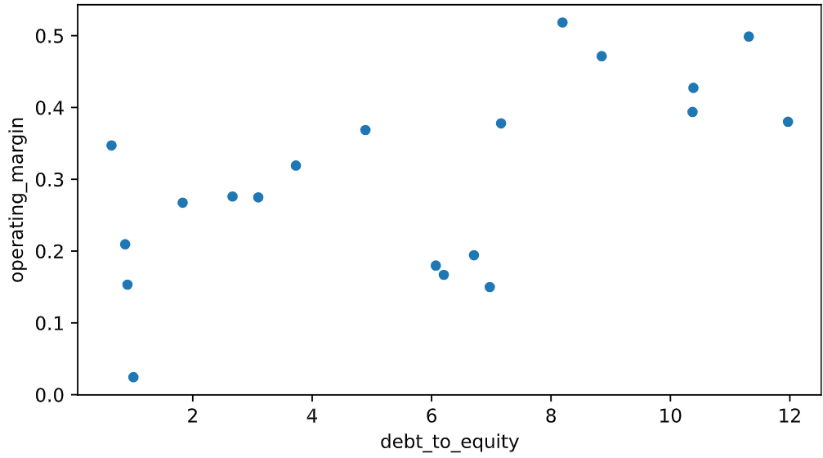

* Find relationship:

def make_plot_updated(dataset, x, y, kind, comp_type):

whole_dat = []

for industry in comp_type:

dat = dataset.loc[dataset["comp_type"]==industry]

values = [x,y if y!="Year" else x]

dat_avg = dat.pivot_table(index="Year",

values=values).reset_index()

dat_avg = dat_avg.loc[:,

~dat_avg.columns.duplicated()]

dat_avg["company"] = f"Avg {industry}"

dat_avg["comp_type"] = industry

whole_dat.append(pd.concat([dat, dat_avg]))

plot_df = pd.concat(whole_dat).reset_index(drop=True)

sns.relplot(data=plot_df,

x=x,

y=y,

hue="company",

col="comp_type",

kind=kind)

plt.show()

plt.close()

* + additional explonation:

 (1) values = [x,y if y!="Year" else x] – takes out "Year" from y argument.

(2) dat_avg = dat_avg.loc[:,~dat_avg.columns.duplicated()] – drops duplicate columns from df_avg.

result:

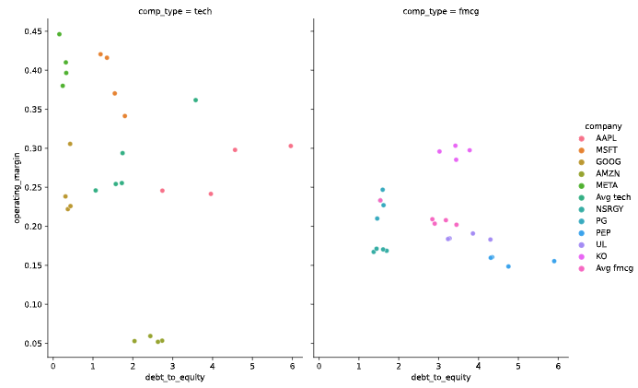

#### More on analyzing profitability

* Need to combine those pictures.
* Heatmap for analyzing industry correlation:

corr_mat = merged_dat[["Gross Margin", "Operating Margin",

                        "Debt-to-equity","Equity Multiplier",

                        "Current Ratio"]].corr()

sns.heatmap(corr_mat, annot=True)

plt.show()

plt.close()

result:

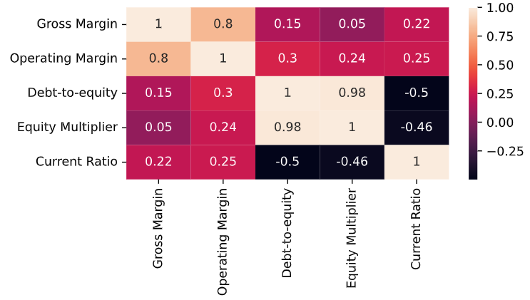

* Barchart for dynamical comparisson of the companies’ ratios:
  + Analysis of the metrics between industries and their companies:

company_avg = statement_info.pivot_table(

                index=["company", "comp_type"],

                values=["debt_to_equity", "current_ratio",

                        "asset_turnover", "gross_margin"]).reset_index()

industry_avg = statement_info.pivot_table(

                index=["comp_type"],

                values=["debt_to_equity","current_ratio",

                        "asset_turnover", "gross_margin"]).reset_index()

industry_avg["company"] = "average"

plot_df = pd.concat([company_avg, industry_avg])

melt_df = plot_df.melt(

    id_vars = ['company', 'comp_type'],

    value_vars = ["debt_to_equity","current_ratio",

                    "asset_turnover", "gross_margin"],

    value_name = "Ratio")

sns.catplot(

    data = melt_df,

    x = 'Ratio', y = 'company',

    row = 'variable', col = 'comp_type',

    kind = 'bar',

    sharey=False)

plt.subplots_adjust(hspace=0.25, wspace=2)

plt.show()

plt.close()

result:

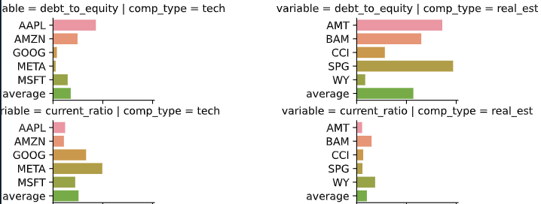

## Financial Forecasting in Python

### Income statements

#### Introduction to financial statements

* Financial statement – they are records, that outline financial activities of a an economic entity.

Financial statements are meant to present the financial information of the entity in question as clearly and concisely as possible in order for users to understand the financial health of the company and be able to make decisions

* + Types of financial statements:



* Profit and loss statement:

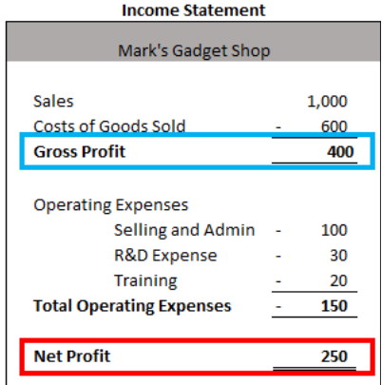

* + Gross profit (direct sales and profits):

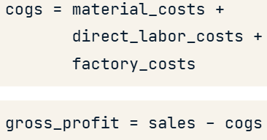

* + - COGS does not include administration or marketing costs, only *costs directly related to production* or providing the good or service.
  + Net profit (indirect sales and profits).

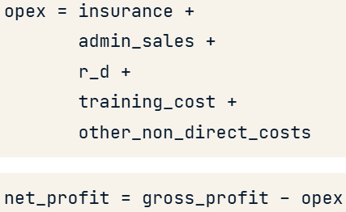

* + - opex – other operating expenses.
    - The net profit includes all the other costs (and all other income) that may incur or earn that is not directly related to the product.  For example the salary of the accountant who prepares your invoices, the advertising budget, travel expenses, etc.

#### Calculating sales & Cost of Goods Sold (COGS)

* Calculating sales:

What is it: 

* Process:

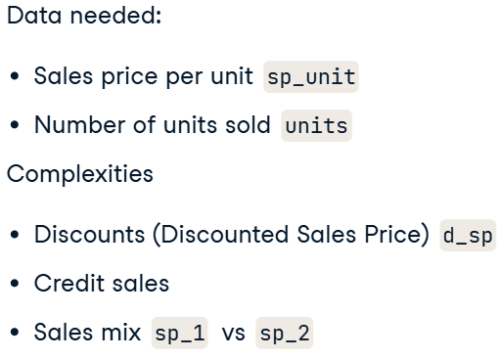

* Calculating COGS:
  + formula:

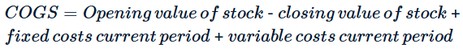

* + data needed:

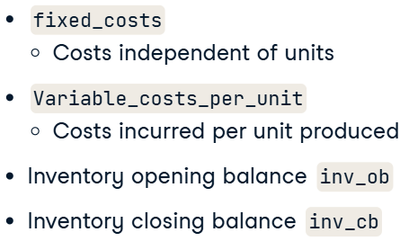

* + fixed costs in COGS – are costs directly related to the product but are incurred whether you produce the products or not.
  + inventory closing balance – залишок запасів на кінець періоду.
* What does the gross profit tell us:
  + Analysing the profitability of out product.
    - If we are not making a profit, then we need to look very carefully our process and even at the product itself to see whether it can be improved.
    - break-even point – точка беззбитковості.
  + Formula for break-even amount:



* Sales calculation:

salesprice_basic = 15   # 0.6

salesprice_custom = 25  # 0.4

forecast_units = 500

# Calculate the combined sales price taking into account the sales mix

average_sales_price = (15 * 0.6) + (25 * 0.4)

# Calculate the total sales for next month

sales_USD = forecast_units * average_sales_price

# Print the total sales

print("Next month's forecast sales figure is {:.2f} USD.".format(sales_USD))

* + explonation:

This is a simple sales mix example. Sales mix can fluctuate every month, and have a big effect on the total Sales in USD.

* Sales with discount:

# Forecast the sales of January

sales_january = units_january * sales_price

# Forecast the discounted price

dsales_price = sales_price * 0.6

# Forecast the sales of February

sales_february = (units_february * 0.45 * dsales_price) + (units_february * sales_price*0.55)

# Print the forecast sales for January and February

print("The forecast sales for January and February are {} and {} USD respectively.".format(sales_january, sales_february))

* Cost per unit:

machine_rental = 1300 # fixed costs

material_costs_per_unit = 8

labor_costs_per_unit = 2

units_jan = 200

units_feb = 250

fixed_costs = machine_rental

variable_costs_per_unit = material_costs_per_unit + labor_costs_per_unit

cogs_jan = (units_jan * variable_costs_per_unit) + fixed_costs

cogs_feb = (units_feb * variable_costs_per_unit) + fixed_costs

# Calculate the unit cost for January and February

unit_cost_jan = cogs_jan / units_jan

unit_cost_feb = cogs_feb / units_feb

# Print the January and February cost per unit

print("The cost per unit for January and February are {} and {} USD respectively.".format(unit_cost_jan, unit_cost_feb))

* Break even point:

fixed_costs = 1300

variable_costs_per_unit = 10

units_jan = 200

units_feb = 250

sales_price = 16

break_even = fixed_costs / (sales_price - variable_costs_per_unit)

# Print the break even point in units

print("The break even point is {} units.".format(round(break_even)))

# Forecast the gross profit for January and February

gross_profit_jan = units_jan * sales_price - cogs_jan

gross_profit_feb = units_feb * sales_price - cogs_feb

# Print the gross profit for January and February

print("The gross profit for January and February are {} and {} USD respectively.".format(gross_profit_jan, gross_profit_feb))

result:



#### Working with raw forecast datasets

* **Trailing Twelve Months (TTM)** — финансовый показатель, отражающий данные за последние 12 месяцев.
* Inserting a new column to a DF:

filtered_income_statement.insert(n_cols, column='Forecast', value=13000)

result:

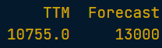

### Balance sheet and forecast ratios

#### Introduction to the balance sheet

* Balance Sheet:

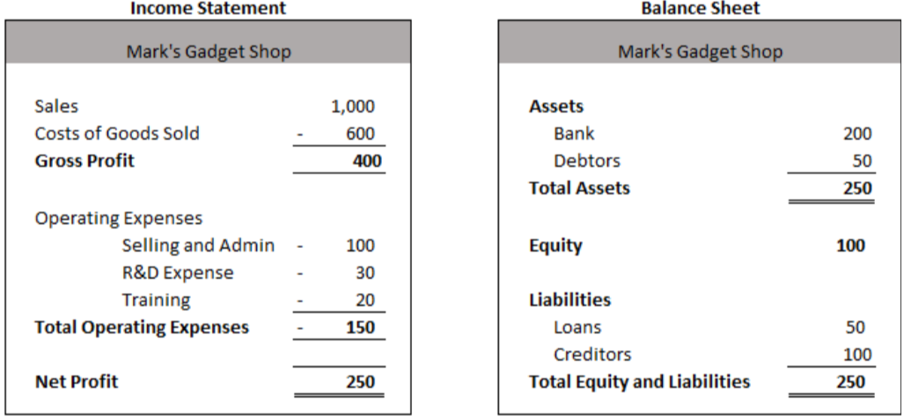

* + Additional info:

При продаже в кредит выручка фиксируется в отчёте о прибылях и убытках, а в балансе отражается как дебиторская задолженность.

Также можно покупать в кредит, создавая обязательства к оплате в будущем. Они учитываются как кредиторская задолженность в BS. Включаются в COGS и OPEX.

* + Example:

When we sell something on credit, the credit portion is in the balance sheet under ‘Accounts Receivable’ or ‘Debtors’. For example, if credit sales are made in January with a 60-day payback period, they would be recorded in our ‘Debtors’ account in January, but only be paid (released) in March, and so on.

* “Bad debts” influence:

This affects both the income statement and the balance sheet:

* + In the income statement, we record a negative value in the sales for the month we write off the debt.
  + In the balance sheet, we need to reduce our debtor’s asset.
* Additional info:

The balance sheet shows us what our real cash situation looks like, as just because we made a sale does not mean money in the bank, and incurring an expense also does not mean we have to pay it right away.

#### Balance sheet efficiency ratios

* Debtor days ratio:
  + What is it:



* + Explonation:

You can imagine if your salary was late, what a difficult position this would put you in and you would either need to go: in debt; rely on your savings to fulfill your obligations.

But this can be managed as well, and good companies are able to manage their debtors without ending up in a bad cash flow situation.

* + Formula:

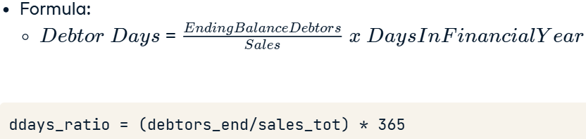

* Days payable outstanding (DPO) – непогашенная кредиторская задолженность в днях:
  + What is it:



* + Formula:

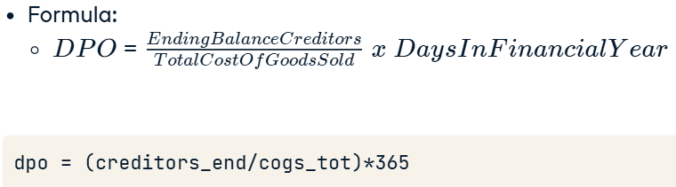

#### Balance sheet efficiency ratios - Part 2

* Days in inventory (DII):
  + What is it:



* + Formula:



* + - the stock of inventory – запас ТМЗ.

## Manipulating Time Series Data in Python

### Working with Time Series in Pandas

#### Dates & times with pandas

* Sequence of dates and periods:

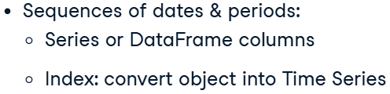

* Timestamp in Pandas:

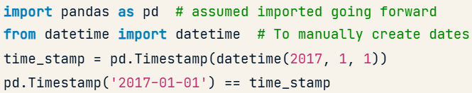

* + Attributes and methods:
    - Methods: time_stamp.day_name()
    - Attributes:

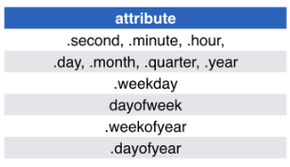

* Period in Pandas:

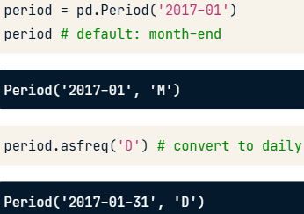

* + - Frequency in dates:

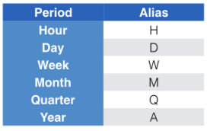

* + - * B – business day frequency.
  + From period to timestamp and again to period:

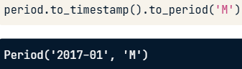

* Arithmetic operations:

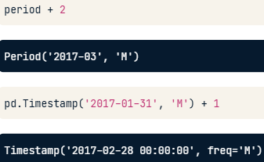

* Create a sequence of dates and times:

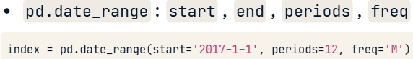

* + pd.DatetimeIndex is a series of pd.Timestamp

#### Indexing & resampling time series

* Time series transformation:

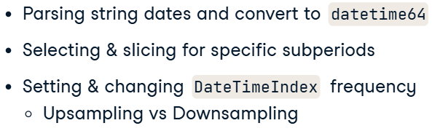

* From string to date (parsing):

data['date'] = pd.to_datetime(data['date'])

* Time series DataFrame:

data.set_index('date', inplace=True)

result:

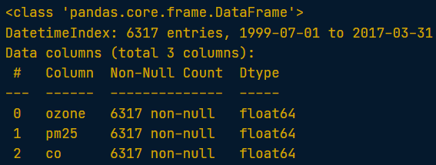

* Selecting and slicing the specific periods:



* Setting frequency of the time series (up- and downsampling):

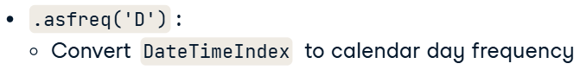

* + Code:

co = co.asfreq(freq='D')

* Plotting:

prices.plot(subplots=True)

plt.show()

result:

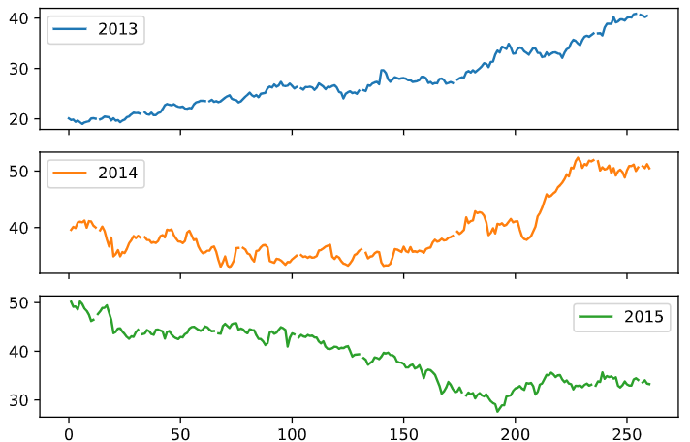

#### Lags, changes, and returns for stock price series

* Time series manipulations:

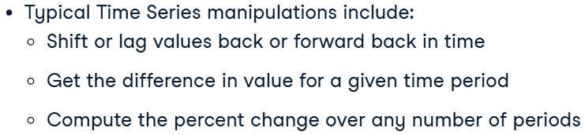

* Time series data importing:



* All those methods have keyword “periods” – to have n periods apart.
  + example of return:

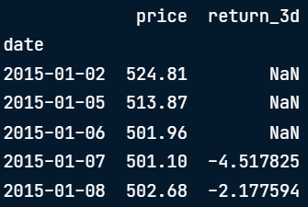

* Shift data:

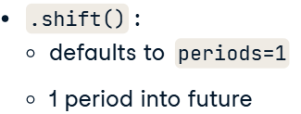

* + future value in the past (lagged): periods=–n
  + vise versa (shifted): periods=n
  + Code:

google['lagged'] = google.Close.shift(periods=-90)

* One-period percent change (return):
  + Formula:

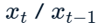

* + Code:





* + - div ­– divide; sub – subtract; mul – multiply.
* Difference in values:
  + Formula:

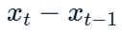

* + Code:

yahoo['diff_30'] = yahoo['price'].diff(periods=30)

* Percent change:
  + Formula:

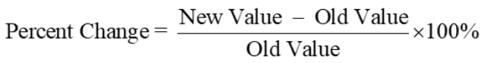

* + Code:

google['monthly_return'] = google.Close.pct_change(periods=30).mul(100)

### Basic Time Series Metrics & Resampling

#### Compare time series growth rates

* Comparing stock perfomance (hard to compare, as they have a start at different points):
  + Solution:

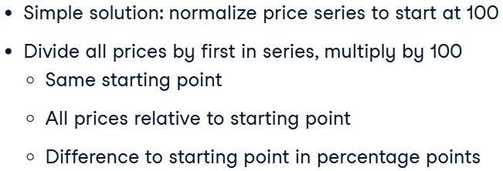

* + Code:

first_prices = prices.iloc[0]

normalized = prices.div(first_prices).mul(100)

result:

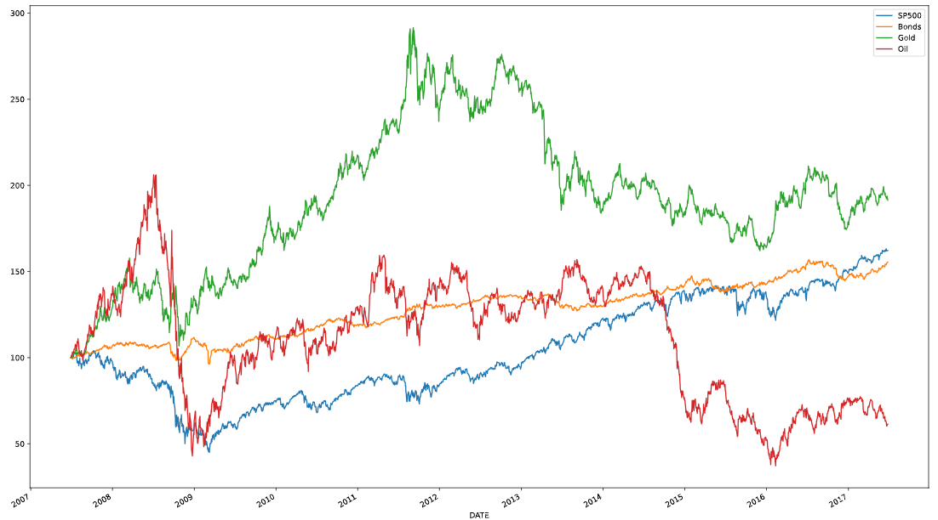

* Showing the performance difference for each stock relative to the benchmark in percentage points:
  + You can subtract the normalized SP500 from the normalized stock prices.
  + В результате получим DataFrame, где каждая ячейка показывает, на сколько процентных пунктов акция превзошла или отстала от S&P 500 в соответствующий день.
  + Code:

tickers = ['MSFT', 'AAPL']

stocks = pd.read_csv('msft_aapl.csv', parse_dates=['date'], index_col='date')

sp500 = pd.read_csv('sp500.csv', parse_dates=['date'], index_col='date')

data = pd.concat([stocks, sp500], axis=1).dropna()

normalized = data.div(data.iloc[0]).mul(100)

normalized[tickers].sub(normalized['SP500'], axis=0).plot()

plt.show()

result:

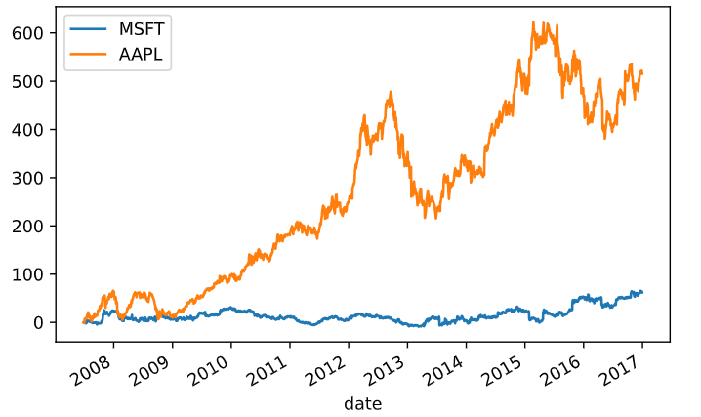

#### Changing the time series frequency: resampling

* Resampling:

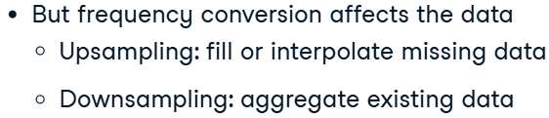

* Missing values with upsampling (how to eliminate):
  + Filling:

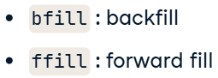

* + Code:

data = pd.read_csv('unemployment.csv',

                    parse_dates=['date'],

                    index_col='date')

print(data.asfreq(freq='W', method='bfill').head())

* .reindex() – более гибкий в использовании:
  + when to use:
    - Надо привести индекс к определенному списку значений.
    - Создать новый индекс.
  + missing values inputing the same as in .asfreq()
  + code:

start = '2016-1-1'

end = '2016-2-29'

monthly_dates = pd.date_range(start=start, end=end, freq='M')

monthly = pd.Series(index=monthly_dates,

                    data=[1, 2])

weekly_dates = pd.date_range(start=start, end=end, freq='W')

print(monthly.reindex(weekly_dates))

* + fillna:

print(monthly.reindex(weekly_dates))

print(monthly.reindex(weekly_dates, method='bfill'))

print(monthly.reindex(weekly_dates, method='ffill'))

print(monthly.reindex(weekly_dates, fill_value=0))

* Data interpolation:

weekly_dates = pd.date_range(start=monthly.index.min(), end=monthly.index.max(),

                                freq='W')

weekly = monthly.reindex(weekly_dates)

weekly['ffill'] = weekly.UNRATE.ffill()

weekly['interpolated'] = weekly.UNRATE.interpolate()

result:

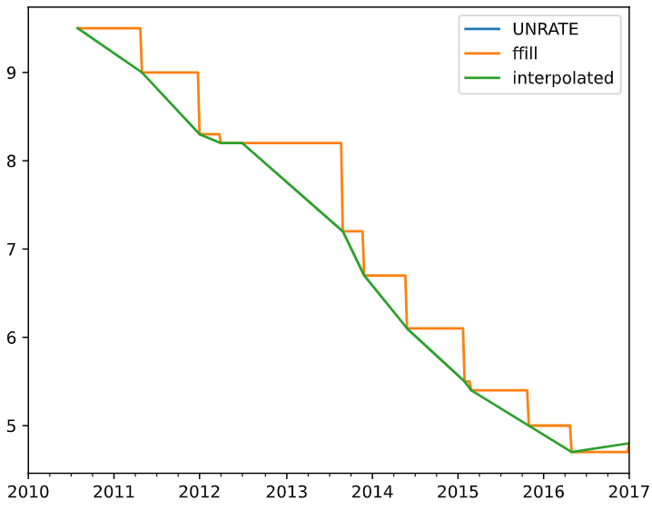

#### Upsampling & interpolation with .resample()

* Resample method:

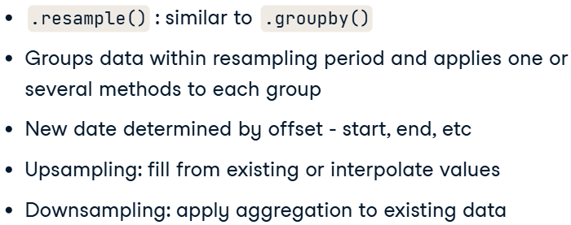



* + Why should use:
    - Если нужно просто изменить частоту и заполнить пропуски, то asfreq() удобнее.
    - Если нужно сгенерировать новые значения (интерполяция, средние и т. д.), то resample() незаменим.
* Calendar month date:

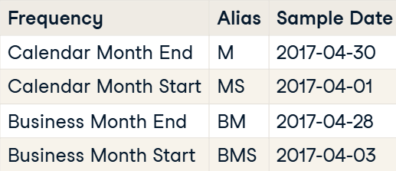

* Resampling logic:
  + date offset – смещение даты.
  + Upsampling:

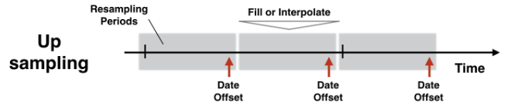

* + Downsampling:

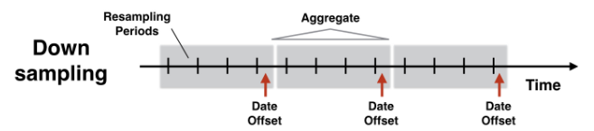

* Interpolate values with resampling (upsampling):
  + Code with .ffill():



* + Code with .interpolate():



* Adding secondary axis:

interpolated.plot(secondary_y='Unemployment')

plt.show()

#### Downsampling & aggregation

* Downsampling:

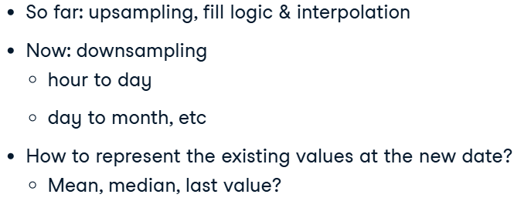

* Code:

df.resample('D').asfreq() полезно, если ты хочешь добавить пропущенные даты, но не агрегировать данные.

* Creating monthly aggregated frequrnecy:

ozone.resample('M').mean().plot()

* Several aggs:

stats = daily_returns.resample('M').agg(['mean', 'median', 'std'])

* Plotting resampled data:

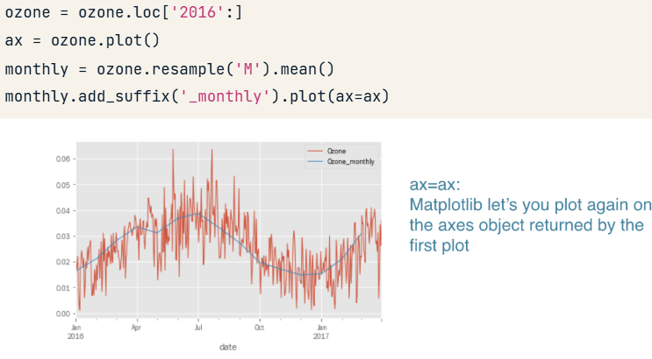

### Window Functions: Rolling & Expanding Metrics

#### Rolling window functions with pandas

* Window functions:

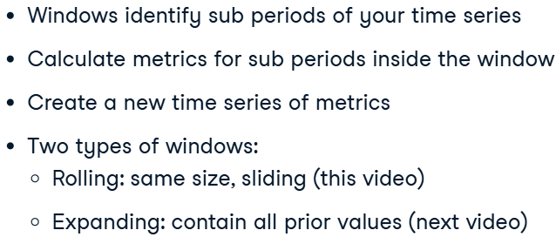

* Extracting first value of TimeSeries:

first_value = market_cap.first('D')

last_value = market_cap.last('D')

* Code for mooving average:



* + defining days:

data['90D'] = data.Ozone.rolling('90D').mean()

* Several metrics (for exploring volatility):

rolling_stats = data.Ozone.rolling(360).agg(['mean', 'std'])

* + Another way (to describe changes in the dispersion of a time series over time in a way that is less sensitive to outliers than using the mean and standard deviation):

data = data.resample('D').interpolate()

print(data.info())

rolling = data.Ozone.rolling(360)

data['q10'] = rolling.quantile(0.1)

data['q50'] = rolling.quantile(0.5)

data['q90'] = rolling.quantile(0.9)

data.plot()

plt.show()

result:

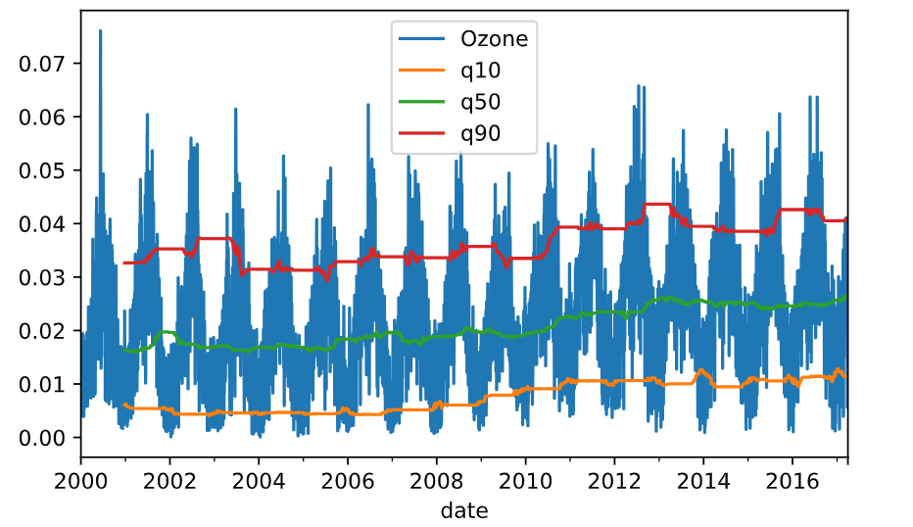

#### Expanding window functions with pandas

* Expanding window:

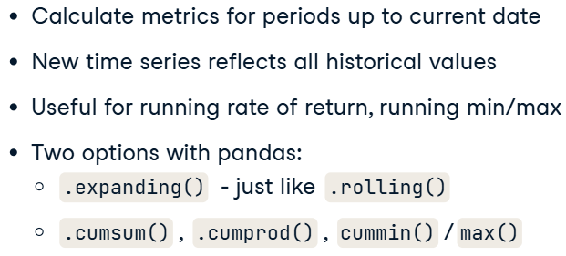

* Code for expanding window:

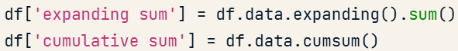

* Running rate of return:

investment = 1000

returns = data.pct_change()

returns_plus_one = returns.add(1)

cumulative_return = returns_plus_one.cumprod().sub(1)

cumulative_return.mul(investment).plot()

plt.show()

result:

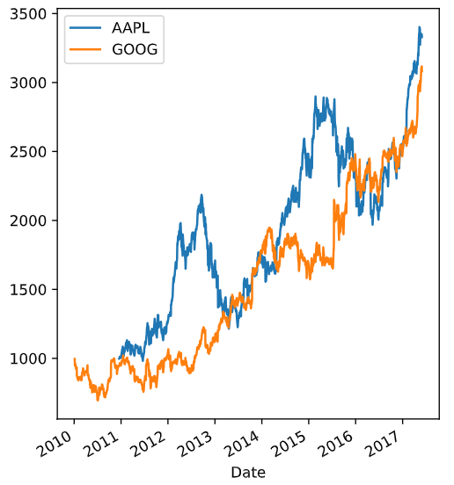

* Annual rate of return:

def multi_period_return(period_returns):

    return np.prod(period_returns + 1) - 1

daily_returns = data.pct_change()

rolling_annual_returns = daily_returns.rolling('360D').apply(multi_period_return)

rolling_annual_returns.mul(100).plot()

plt.show()

return:

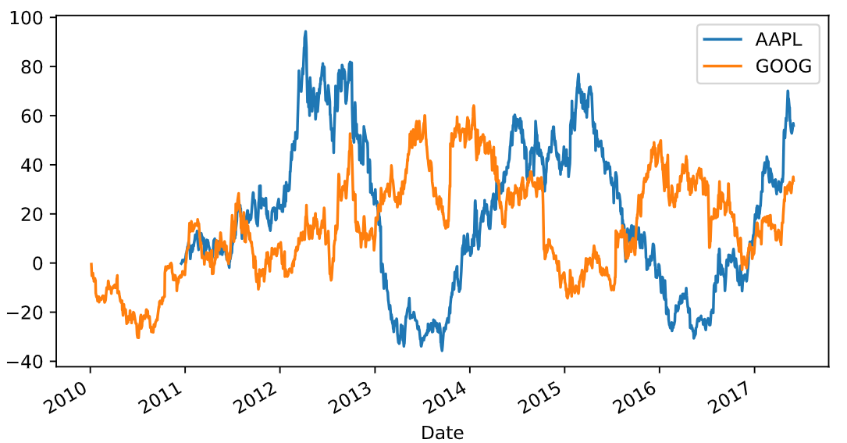

#### Random walk

* Process:

seed(42)

daily_returns = fb.pct_change().dropna()

n_obs = daily_returns.count()

random_walk = choice(daily_returns, size=n_obs)

random_walk = pd.Series(random_walk)

start = fb.price.first('D')

# Add 1 to random walk and append to start

random_walk = random_walk.add(1)

random_price = start.append(random_walk)

# Calculate cumulative product here

random_price = random_price.cumprod()

# Insert into fb and plot

fb['random'] = random_price

fb.plot()

plt.show()

result:

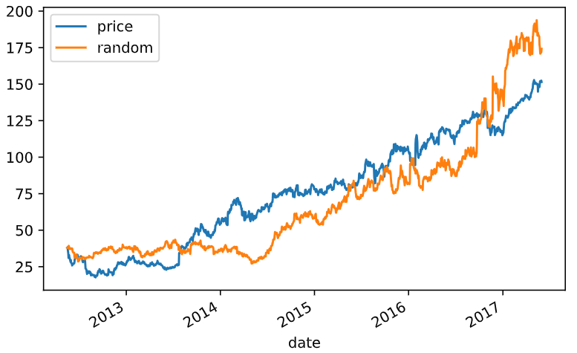

#### Relationships between time series: correlation

* Whst is it:

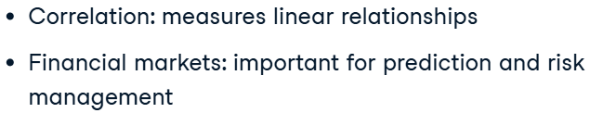



* Visualize pairwise relationship:

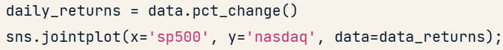

* Heatmap for correlations:

annual_prices = data.resample('A').last()

annual_returns = annual_prices.pct_change()

correlations = annual_returns.corr()

sns.heatmap(correlations, annot=True)

plt.show()

### Putting it all together: Building a value-weighted index

#### Select index components & import data

* Market value-weighted index:

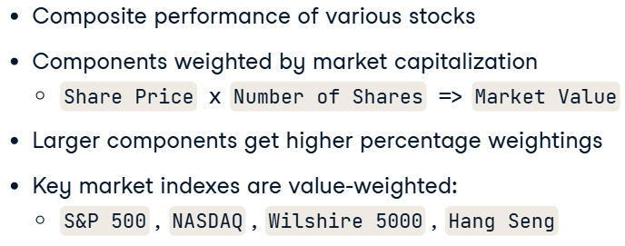

* Selecting the largest company, using .nlargest():



* Цифры в нужном формате:



* Extracting values from index, which consist of filtered values:

components = listings.groupby('Sector')['Market Capitalization'].nlargest(1)

print(components.sort_values(ascending=False))

tickers = components.index.get_level_values('Stock Symbol').tolist()

print(tickers)

info_cols = ['Company Name', "Market Capitalization", "Last Sale"]

print(listings.loc[tickers, info_cols]

            .sort_values('Market Capitalization', ascending=False))

result:

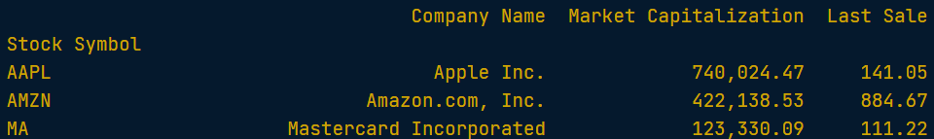

/\

stock_prices = pd.read_csv('stock_prices.csv',

                            parse_dates=['Date'],

                            index_col='Date').iloc[:, tickers]

print(stock_prices.info())

price_return = stock_prices.iloc[-1].div(stock_prices.iloc[0]).sub(1).mul(100)

price_return.sort_values().plot(kind='barh',

                                title='Stock Price Returns')

plt.show()

result:

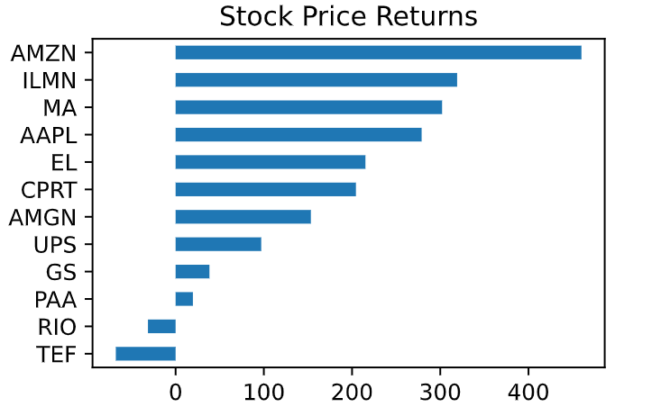

#### Evaluate index performance

* Evaluating:

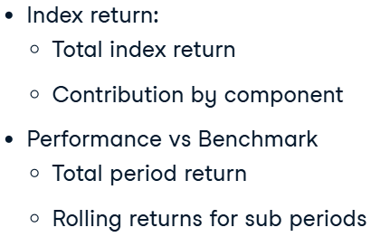

#### Exporting to Excel

* Exporting:

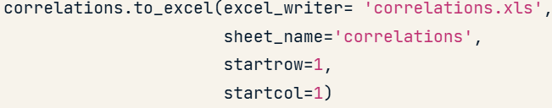

* Saving multiple worksheets:

with pd.ExcelWriter('data.xls') as writer:

    data.to_excel(excel_writer=writer, sheet_name='data')

    returns.to_excel(excel_writer=writer, sheet_name='returns')

## Importing and Managing Financial Data

### Importing stock listing data from Excel

#### Reading data from CSV

* Importing data with missing values and dates:

nasdaq = pd.read_csv('nasdaq-listings.csv',

                    na_values='NAN',  # or any other string, which represents np.nan

                    parse_dates=['Last Update'])

#### Read data from Excel worksheets

* Importing data from Excel:

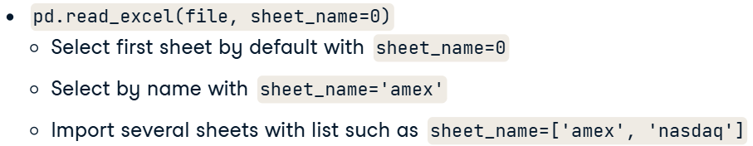

* + Code:

nyse = pd.read_excel('listings.xlsx',

                    na_values='n/a',

                    sheet_name='nyse')

* Getting sheet names from Excel:

xls = pd.ExcelFile('listings.xlsx')

exchanges = xls.sheet_names

listings = pd.read_excel(xls,

                        sheet_name=exchanges,

                        na_values='n/a')

#### Combine data from multiple worksheets

* Code:

xls = pd.ExcelFile('listings.xlsx')

exchanges = xls.sheet_names

listings = []

for exchange in exchanges:

    listing = pd.read_excel(xls, sheet_name=exchange, na_values='n/a')

    listing['Exchange'] = exchange

    listings.append(listing)

listing_data = pd.concat(listings)

print(listing_data.info())

### Importing financial data from the web

#### The DataReader: Access financial data online

* pandas datareader:

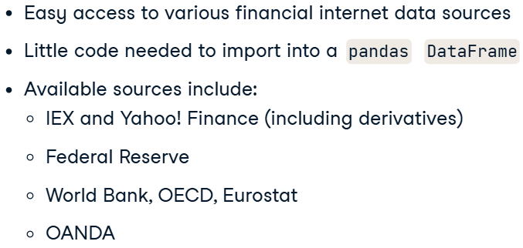

* + source: https://pandas-datareader.readthedocs.io/en/latest/remote_data.html
* Code:

from pandas_datareader.data import DataReader

from datetime import date

start = date(2016, 1, 1)

end = date(2016, 12, 31)

ticker = 'AAPL'

data_source = 'iex'

stock_prices = DataReader(ticker, data_source, start, end)

print(stock_prices.head())

print(stock_prices.info())

#### Economic data from the Federal Reserve

* Economic data from FRED (**Federal Reserve Economic Data**):

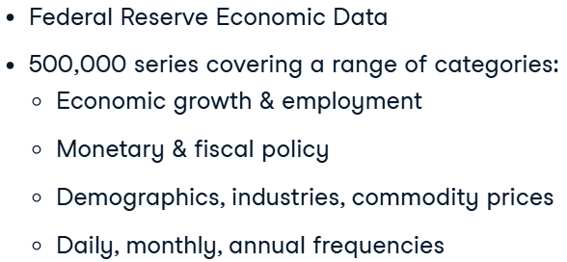

* Importing data:

start = date(1950, 1, 1)

series_code = ['UNRATE', 'CIVPART']

econ_data = DataReader(series, 'fred', start)

* + series_code from FRED
  + Civilian Participation – этот показатель отражает долю гражданского населения, которое либо работает, либо активно ищет работу, по отношению к общей численности трудоспособного населения.
* Combining ecomomic and stock data.

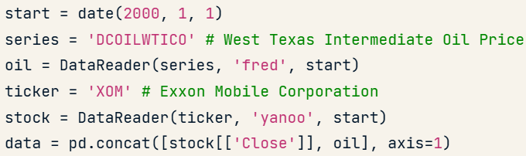

#### Select stocks and get data from Yahoo! Finance

* Selecting stocks based on criteria:

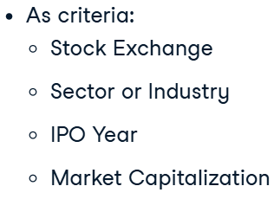

* Get index for the lareges companies:

listings_ss = listings.set_index('Stock Symbol')

ticker = listings_ss.loc[listings_ss.Sector == 'Consumer Services',

                            'Market Capitalization'].idxmax()

start = date(2015, 1, 1)

data = DataReader(ticker, 'yahoo', start)

data[['close', 'volume']].plot(secondary_y='volume', title=ticker)

plt.show()

* + idxmax() — это метод в pandas, который возвращает индекс первого максимального значения в Series или DataFrame по заданной оси.

result:

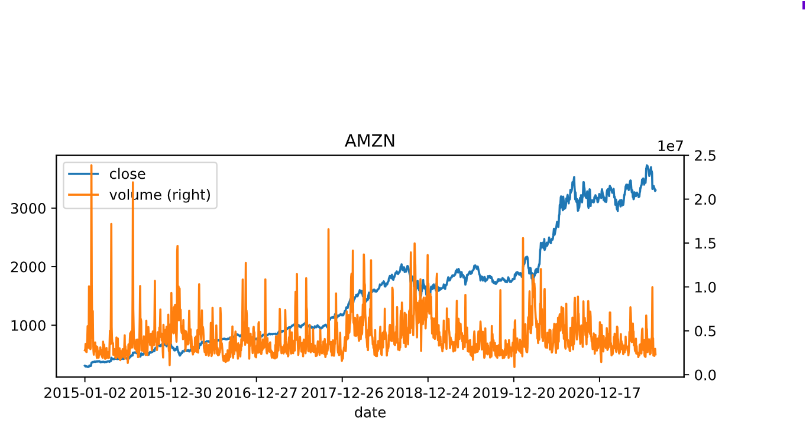

#### Get several stocks & manage a MultiIndex

* From long to wide (unstack):

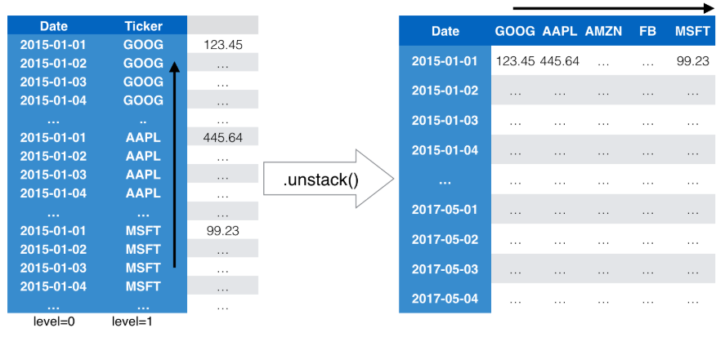

* + Code:

result = DataReader(top_3_tickers, 'iex', start, end)

data = result.stack()

data['close'].unstack().info()

### Summarizing your data and visualizing the result

#### Describe the distribution of your data with quantiles

* Getting quantiles of the distribution:

quantiles = np.arange(.1, .91, 0.1)

deciles = income['Income per Capita'].quantile(quantiles)

#### Visualize the distribution of your data

* Visualizations:

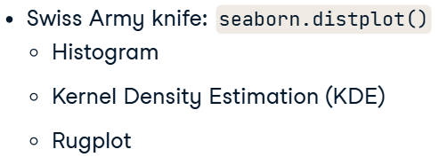

* + creates a **histogram**, where data is grouped into ranges and and plotted as bars;
  + fits a **kernel density estimation (KDE)**, or smoothed histogram.
  + **rugplot** adds markers at the bottom of the chart to indicate the density of observations along the X axis.
* Displot (hist):

sns.displot(df['Award_Amount'],

            bins=20)

plt.show()

result:

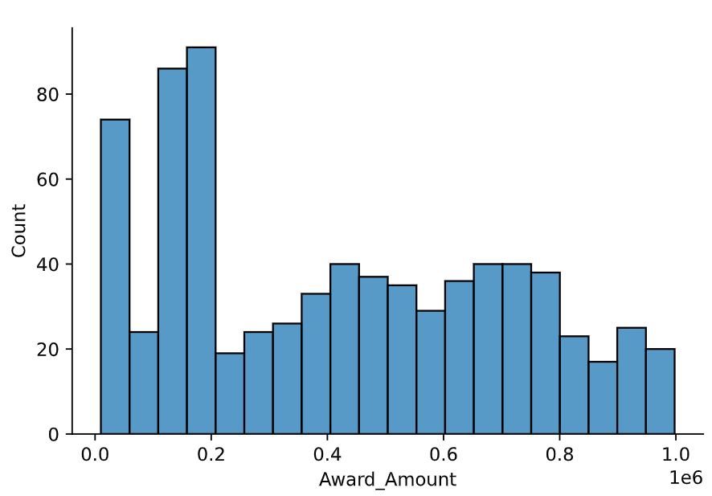

* Kernel Density Estimation:

sns.displot(df['Award_Amount'],

            kde=True,

            fill=True)

plt.show()

result:

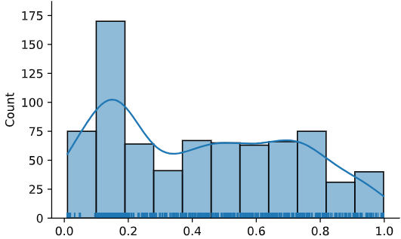

* RUG:

sns.displot(df['Award_Amount'],

            kind='kde',

            fill=True,

            rug=True)

plt.show()

result:

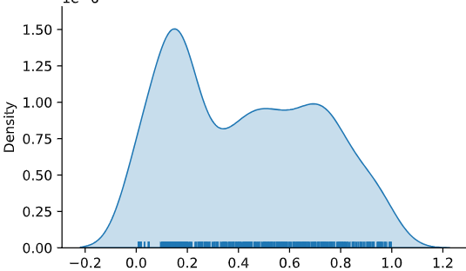

* Empirical Cumulative Distribution Function:

sns.displot(df['Award_Amount'],

            kind='ecdf')

plt.show()

result:

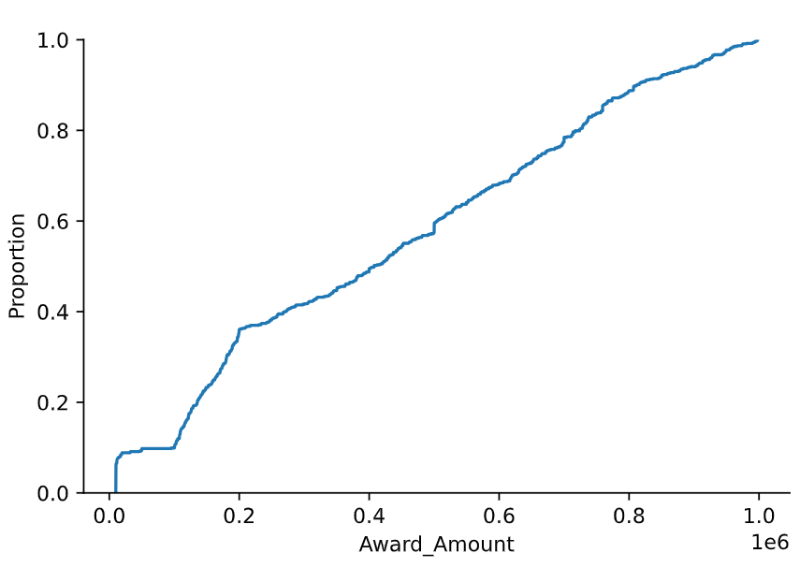

* Customization:

ax.axvline(inc_per_capita.median(), color='g')

result:

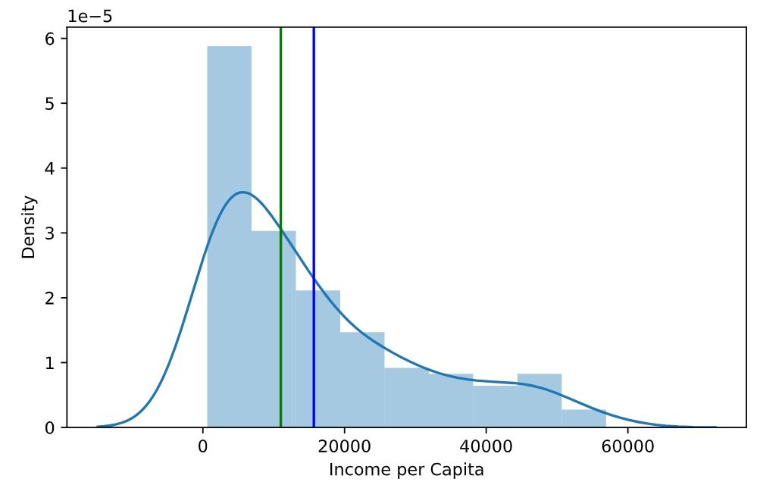

#### Summarize categorical variables

* Catrgorical values exploring:

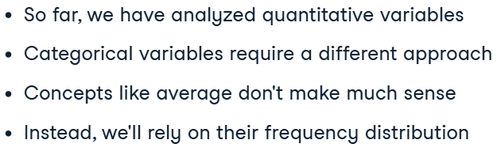

* + A **frequency distribution** is a representation of the number of times that a categorical variable occurs.
* Code:

listings['amex'].apply(lambda x: x.nunique())

* + How much obserbations per sector:



### Aggregating and describing your data by category

#### Aggregate your data by category

* Getting all info about sector with describe():

nasdaq_by_sector = nasdaq.groupby('Sector')

summary = nasdaq_by_sector.describe()

print(summary)

summary = summary.unstack()

print(summary)

result:

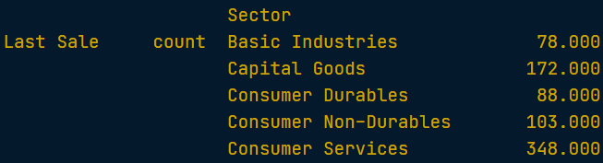

#### More ways to aggregate your data

* Code:



* Selecting from MultiIndex:



* Bar chart for each sector:

by_sector_exchange = listings.groupby(['Sector', 'Exchange'])

mcap_by_sector_exchange = by_sector_exchange['market_cap_m'].agg('median')

print(mcap_by_sector_exchange.head())

mcap_unstacked = mcap_by_sector_exchange.unstack()

title = 'Median Market Capitalization by Exchange'

mcap_unstacked.plot(title=title, kind='bar')

plt.ylabel('USD mn')

plt.xticks(rotation=45)

plt.show()

result:

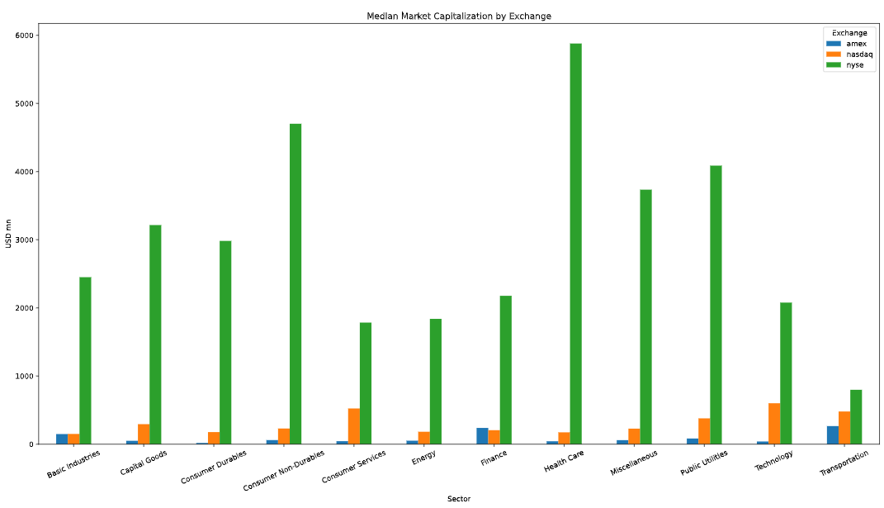

#### Summary statistics by category with seaborn

* Countplot:

sns.countplot(data = listings,

                x = 'IPO Year',

                hue = 'Exchange')

plt.xticks(rotation=45)

plt.show()

result:

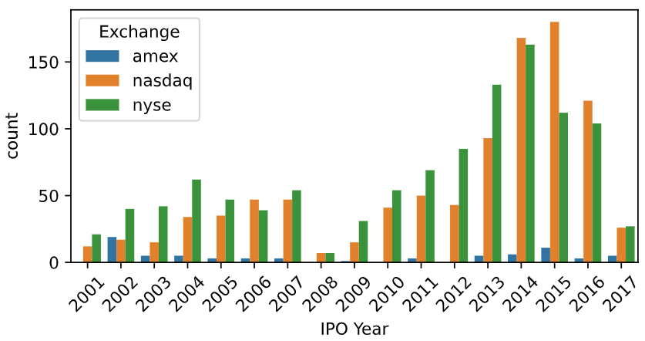

* + Sorted countplot:

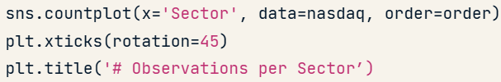

* Barplot – function shows point estimates and confidence intervals as rectangular bars:

sns.barplot(data=income_trend,

            x = 'Year',

            y = 'Income per Capita',

            estimator=np.median)

plt.xticks(rotation=45)

plt.show()

result:

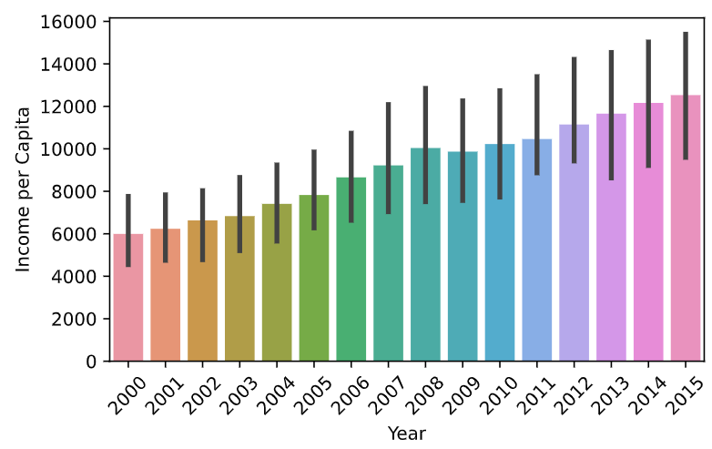

* PointPlot:

sns.pointplot(data=listings,

                x='IPO Year',

                y='market_cap_m',

                hue='Exchange')

plt.xticks(rotation=45)

plt.show()

result:

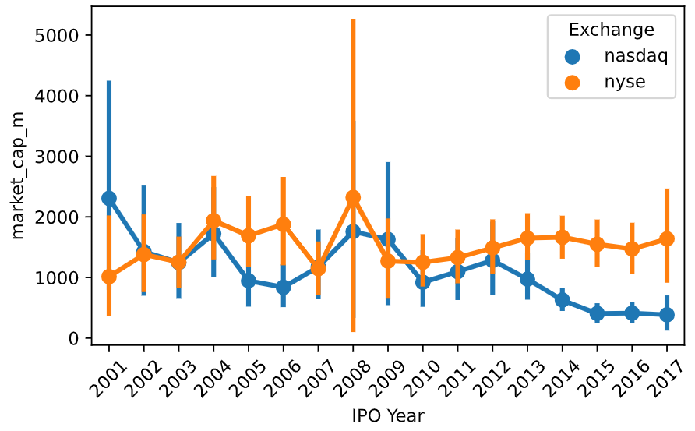

#### Distributions by category with seaborn

* Boxplot:

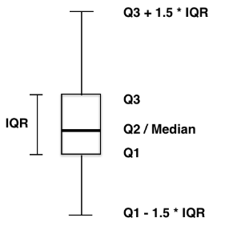

* + Code:

sns.boxplot(data=inflation,

            x='Country',

            y='Inflation')

plt.show()

plt.close()

sns.swarmplot(data=inflation,

            x='Country',

            y='Inflation')

plt.show()

result:

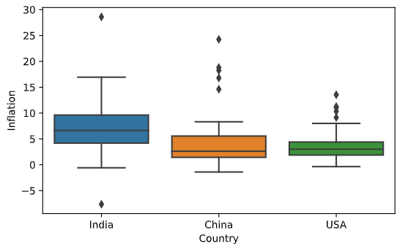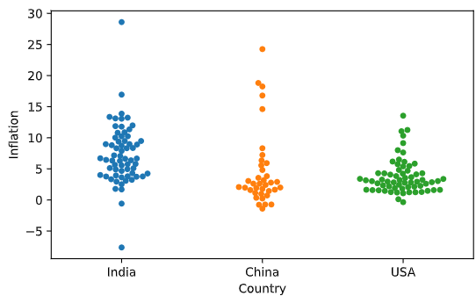

## Introduction to Portfolio Analysis in Python

### Introduction to Portfolio Analysis

#### Welcome to Portfolio Analysis!

* Portfolio, Fund, Index:

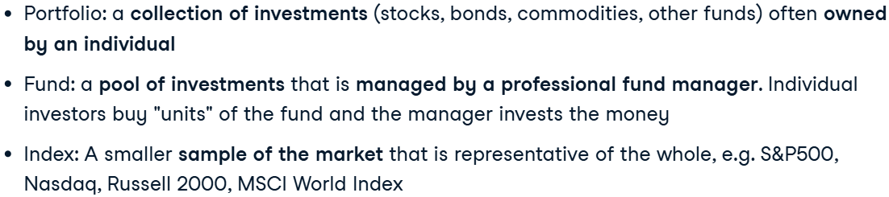

* Diversification:

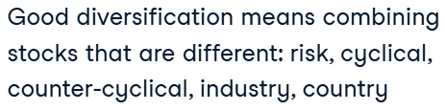

#### Portfolio returns

* Assets’ weight:

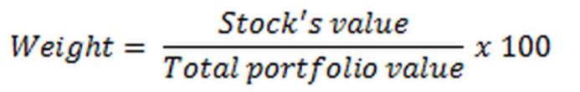

* Returns:

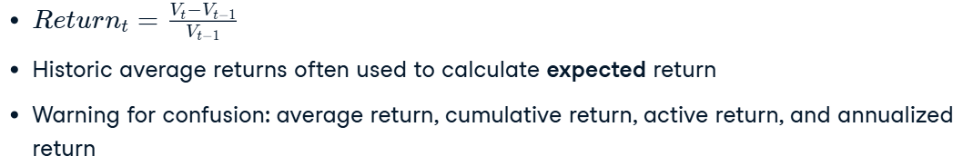

* + Always take into consideration the probability that an asset will achieve its historical return given the current investing environment.
  + Assets, like bonds, are more likely to match their historical returns, while others, like stocks, may vary more widely from year to year.
* Calculating cumulative returns of porfolio (matrix multiplication):



* Mean returns:

returns = data.pct_change()

meanDailyReturns = returns.mean()

weights = np.array([0.5, 0.2, 0.2, 0.1])

portReturn = np.sum(meanDailyReturns * weights)

print(portReturn)

#### Measuring risk of a portfolio

* Variance:

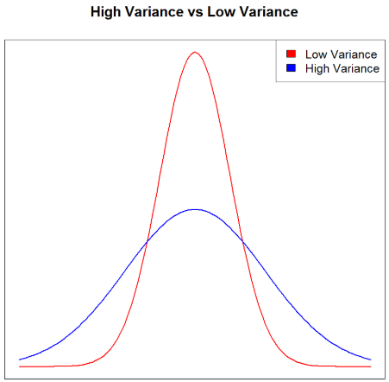

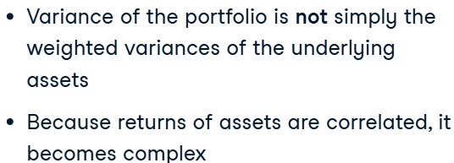

* Portfolio correlation:

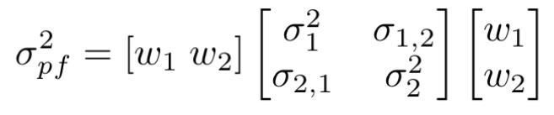



* + Code for Var:

# Get percentage daily returns

daily_returns = data.pct_change()

# Assign portfolio weights

weights = np.array([0.05, 0.4, 0.3, 0.25])

# Calculate the covariance matrix

cov_matrix = (daily_returns.cov())*250

# Calculate the portfolio variance

port_variance = np.dot(weights.T, np.dot(cov_matrix, weights))

# Print the result

print(str(np.round(port_variance, 4) * 100) + '%')

# Calculate the standard deviation by taking the square root

port_standard_dev = np.dot(weights.T, np.dot(cov_matrix, weights.T))**0.5

# Print the results

print(str(np.round(port_standard_dev, 4) * 100) + '%')

* + Interpreting the result:

The standard deviation tells you how much the portfolio's return can deviate from the mean historical return. If a portfolio has a 12% average rate of return and a standard deviation of 4%, its return will range from 8-16%.

### Risk and Return

#### Annualized returns

* Comparing returns:

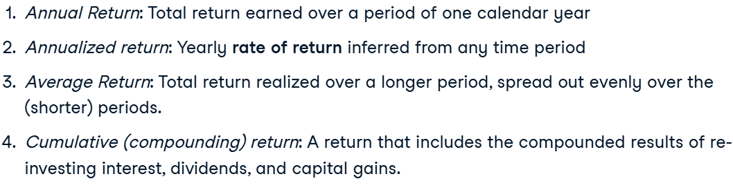

* + *Average returns*, which are often the geometric mean of a return series over a given time span.
  + *Cumulative return*, which is the total return over a period.
  + *Active return*, which is the relative performance to a benchmark.
* Annual and annualized returns:

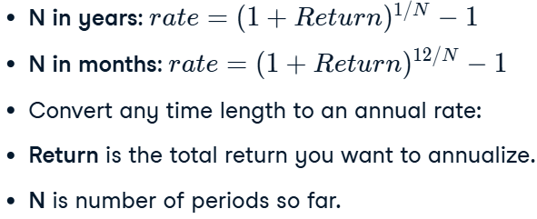

* + N – number of periods.
* Annualized return code (from years to year):

total_return = (pf_AUM[-1] - pf_AUM[0]) / pf_AUM[0]

annualized_return = (1 + total_return) ** (12 / months) - 1

print(annualized_return)

/\

total_return = (sp500_value[-1] - sp500_value[0]) / sp500_value[0]

print(total_return)

annualized_return = (1 + total_return) ** (1/4) - 1

print(annualized_return)

result:

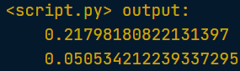

#### Risk adjusted returns

* Risk asjusted return – defines investment return by measuring how much risk is involved in producing that return.
* Sharpe ratio:

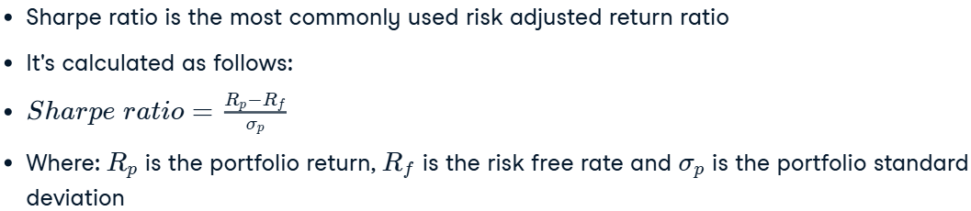

* + When the Sharpe ratio is below 1, the return does not outweigh the risk proportionally.
* Annualized standart deviation:

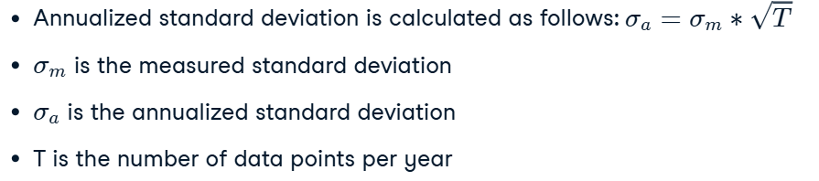

* + T:

Since there are roughly 250 trading days per year, you often multiply with 250. Alternatively when you go from weekly returns to annual, you multiply with 52, etc.

* + Example (uses daily data):

total_return = (sp500_value[-1]  - sp500_value[0]) / sp500_value[0]

annualized_return = (1 + total_return) ** (1/4) - 1

returns_sp500 = sp500_value.pct_change()

annualized_vol_sp500 = returns_sp500.std() * 250**0.5

sharpe_ratio = (annualized_return - rfr) / vol_sp500

print(sharpe_ratio)

result:

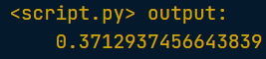

#### Non-normal distribution of returns

* Skewness:

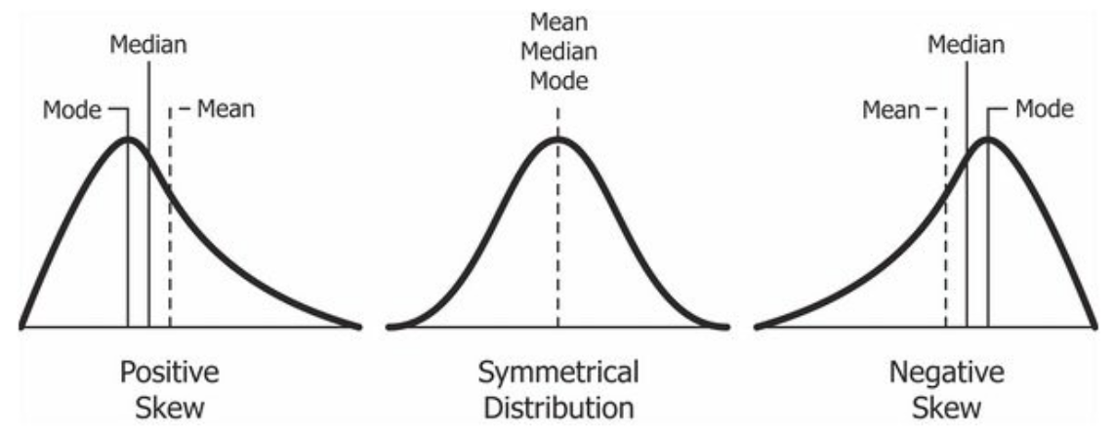

* + Formula:

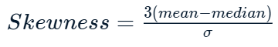

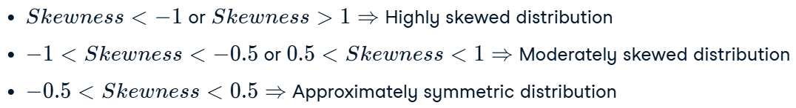

* Kurtosis, fat tailed distribution:

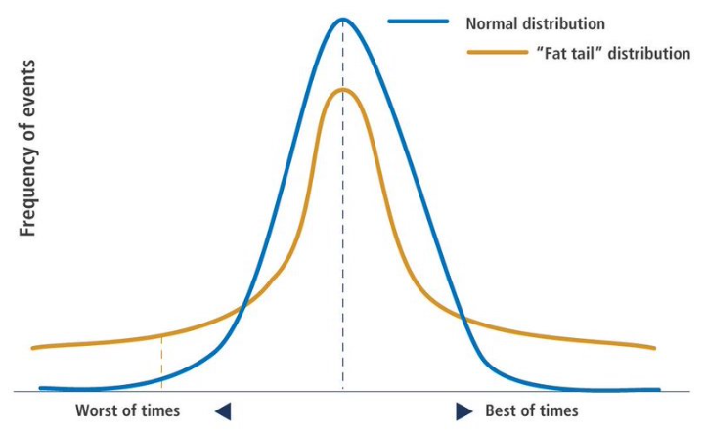

* + Interpretation (ошибка во втором и третьем стейтменте):

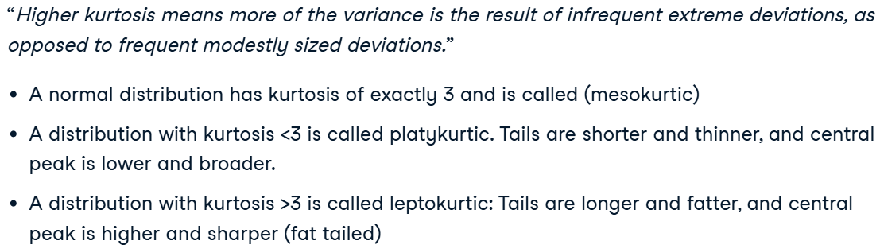

* Algorithm for exploring:
  + Hist;
  + Skewness and kurtosis.
    - Code:

print("mean : ", returns_sp500.mean()*100)

print("Std. dev  : ", returns_sp500.std()*100)

print("skew : ", returns_sp500.skew())

print("kurt : ", returns_sp500.kurtosis())

#### Alternative measures of risk

* Exploring dowside/upside risk:

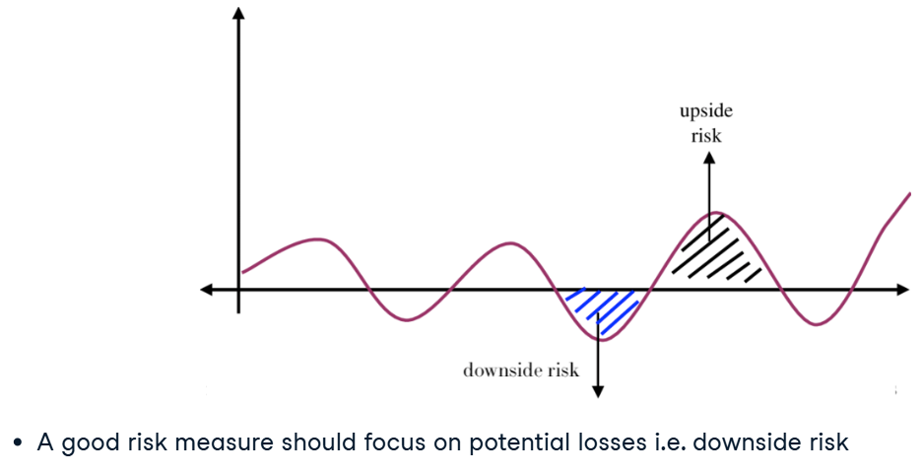

* Sortino Ratio – it uses the standard deviation of the negative returns only, and thereby focuses more on the downside of investing:

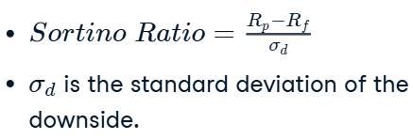

* Downside risk:

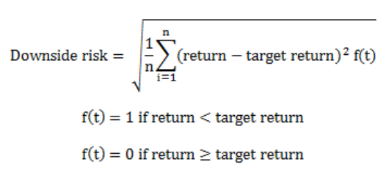

* + Code:

downside_returns = df[df['pf_returns'] < target]

expected_return = df['pf_returns'].mean()

down_stdev = downside_returns.std()

sortino_ratio = (expected_return - rfr) / down_stdev

print("Expected return  : ", expected_return*100)

print("Downside risk   : ", down_stdev*100)

print("Sortino ratio : ", sortino_ratio)

* Maximum draw-down – the largest percentage loss from a market peak to trough.



* Maximum draw-down (peak to trough performance drop) – tells you what has been the worst performance of the S&P500 in the past years:
  + Code (rolling обновляет пик):

# Calculate the max value

roll_max = df.rolling(center=False, min_periods=1, window=252).max()

# Calculate the daily draw-down relative to the max

daily_draw_down = df/roll_max - 1.0

# Calculate the minimum (negative) daily draw-down

max_daily_draw_down = daily_draw_down.rolling(window=252, min_periods=1).min()

# Plot the results

plt.figure(figsize=(15,15))

plt.plot(date, daily_draw_down, label='Daily drawdown')

plt.plot(date, max_daily_draw_down, label='Maximum daily drawdown in time-window')

plt.legend()

plt.show()

result:

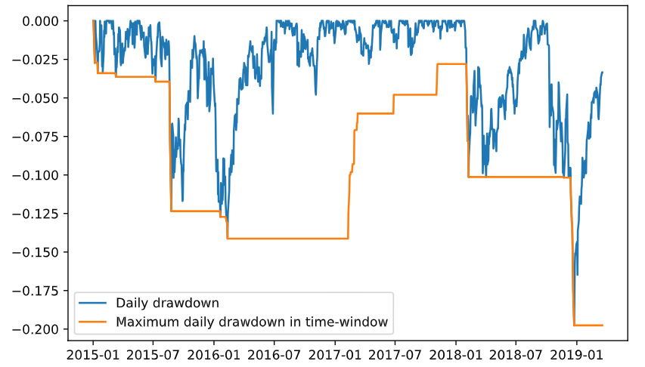

### Performance Attribution

#### Comparing against a benchmark

* Active return (relative to a benchmark):

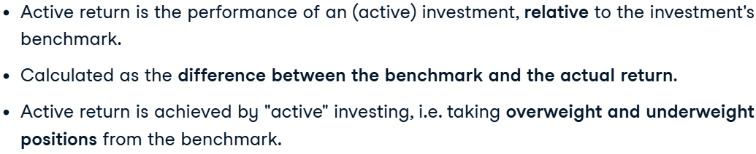

To achieve a better than benchmark result, the portfolio manager needs to take strategic positions that deviate from the benchmark:

Stocks that have a higher weight than the benchmark are *overweight*;

*Underweight* are stocks that have less weight than the benchmark.

* Active return:

# Calculate return of the portfolio

total_return_pf = portfolio_data['mean_return'].dot(portfolio_data['pf_weights'])

# Calculate return of the benchmark

total_return_bm = portfolio_data['mean_return'].dot(portfolio_data['bm_weights'])

# Now you can calculate the active return

active_return = total_return_pf - total_return_bm

print("Active Return: %.2f%%" % active_return)

result:

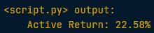

* Active weights (Global Industry Classification System or "GICS"):

print (portfolio_data.bm_weights.sum())

print (portfolio_data.pf_weights.sum())

grouped_df = portfolio_data.groupby('GICS Sector').sum()

# Calculate active weights of portfolio

grouped_df['active_weight'] = grouped_df['pf_weights'] - grouped_df['bm_weights']

print (grouped_df['active_weight'])

result:

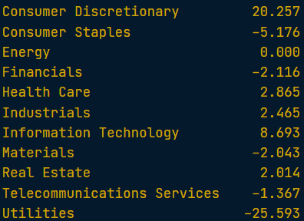

#### Risk factors

* Factors in a stock portfolio (combined characteristics of the portfolio):

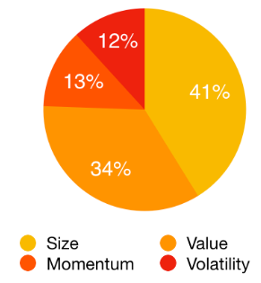

* + Factors are the elements that make up a portfolio return.
* Factors in portfolio:

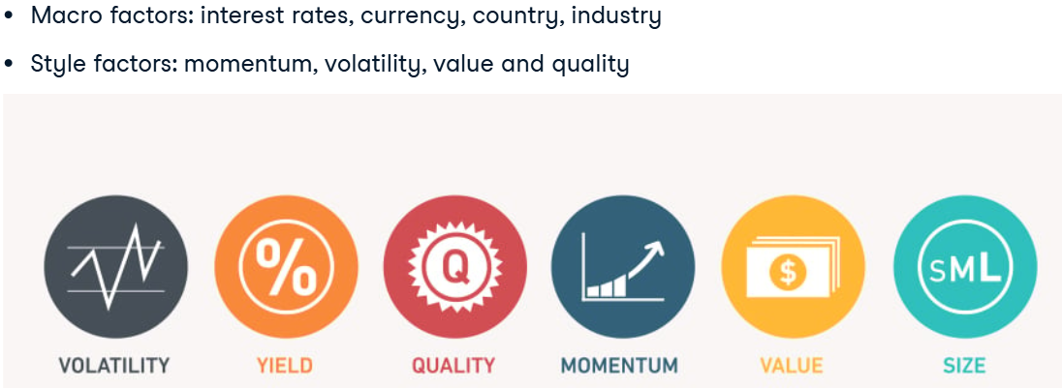

* + **Volatility factor** combines stocks with very low volatility.
  + A stock is showing "**momentum**" if its prior 12-month *average of returns is positive*. The *momentum factor* is therefore formed by combining stocks that show consistent positive historic returns.
  + The **value factor** looks at stocks that are *inexpensive relative to some measure of fundamental value* (P/E; P/B).
  + The **size factor** measures this **difference in return** (дополнительной доходности) between small cap companies relative to large cap companies. Акцент на маленьких компаниях.
    - Since the size factor returns are positive when small cap companies do well relative to large cap, the two should be negatively related to each other.
* Factor models to determine risk exposure (схильність до ризику):

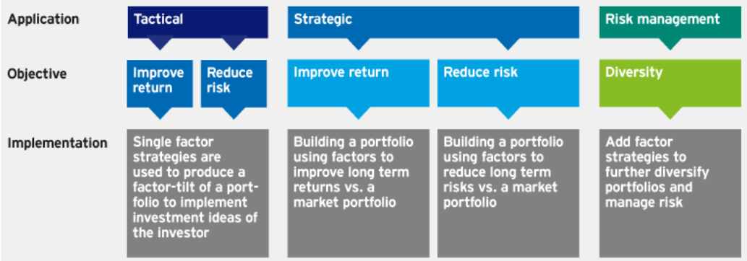

* + *Однофакторные* стратегии используются для создания факторного наклона (приоритета) портфеля с целью реализации инвестиционных идей инвестора.
* Factor exposure:
  + To check how your portfolio relates to investment factors, is to correlate your returns to the factor return.
* Correlation over time:

df['correlation_value']=df['sp500'].rolling(30).corr(df['value'])

* + The change in correlation over time is a result of both changes in our portfolio weights, but also due to changes in the quality factor.
  + The quality factor returns change over time, as well as the underlying composition of companies that make up the factor.

#### Factor models

* Factors:



* Factor models:

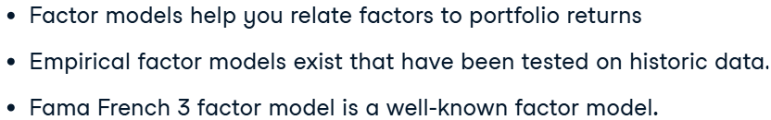

* Fama French MultiFactor model:

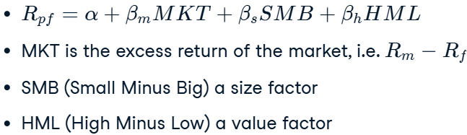

* + MKT = market return – rfr
  + Regression:

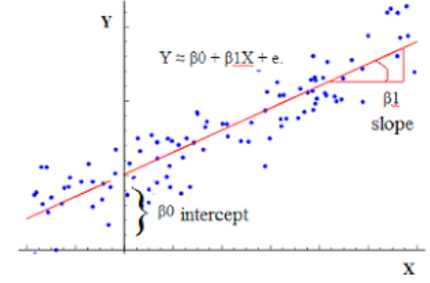

* Code for model:

import statsmodels.api as sm

model = sm.OLS(factor_returns['pf_returns'], factor_returns[['Mkt-RF','SMB','HML']]) .fit()

predictions = model.predict(factor_returns[['Mkt-RF','SMB', 'HML']])

model.summary()

#### Portfolio analysis tools

* Back–tesing:

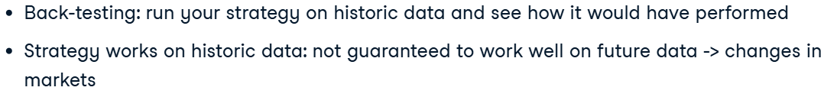

* Pyfolion installment:

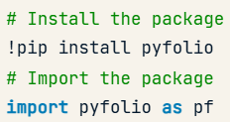

* + Pyfolio также помогает анализировать результаты вашего портфеля, предлагая инструменты для определения факторов доходности (атрибуции) и анализа его распределения по отраслям.
* Code (must be a series):

returns_sp500.index = pd.to_datetime(returns_sp500.index)

returns = returns_sp500['S&P500']

fig = pf.create_returns_tear_sheet(returns,

                                    return_fig=True, live_start_date=’yyyy-mm-dd’)

# Display a zoomed in version of the tear sheet

display_tear_sheet()

* Perfomance attribution and industry exposure tools:

# Define sector mappings

sect_map = {'COST': 'Consumer Goods',

            'INTC': 'Technology',

            'CERN': 'Healthcare',

            'GPS': 'Technology',

            'MMM': 'Construction',

            'DELL': 'Technology',

            'AMD': 'Technology'}

# Create sector exposure tear sheet

pf.create_position_tear_sheet(returns, positions, sector_mappings=sect_map)

display_tear_sheet()

* + returns – returns of the portfolio;
  + positions – everyday porfolio positions.

### Portfolio Optimization

#### Modern portfolio theory